# **C-PROGRAMMING**

**ASSIGNMENT:**

**NAME**: SRIHARI DORNAULA

**QUESTION:1- First C Program**

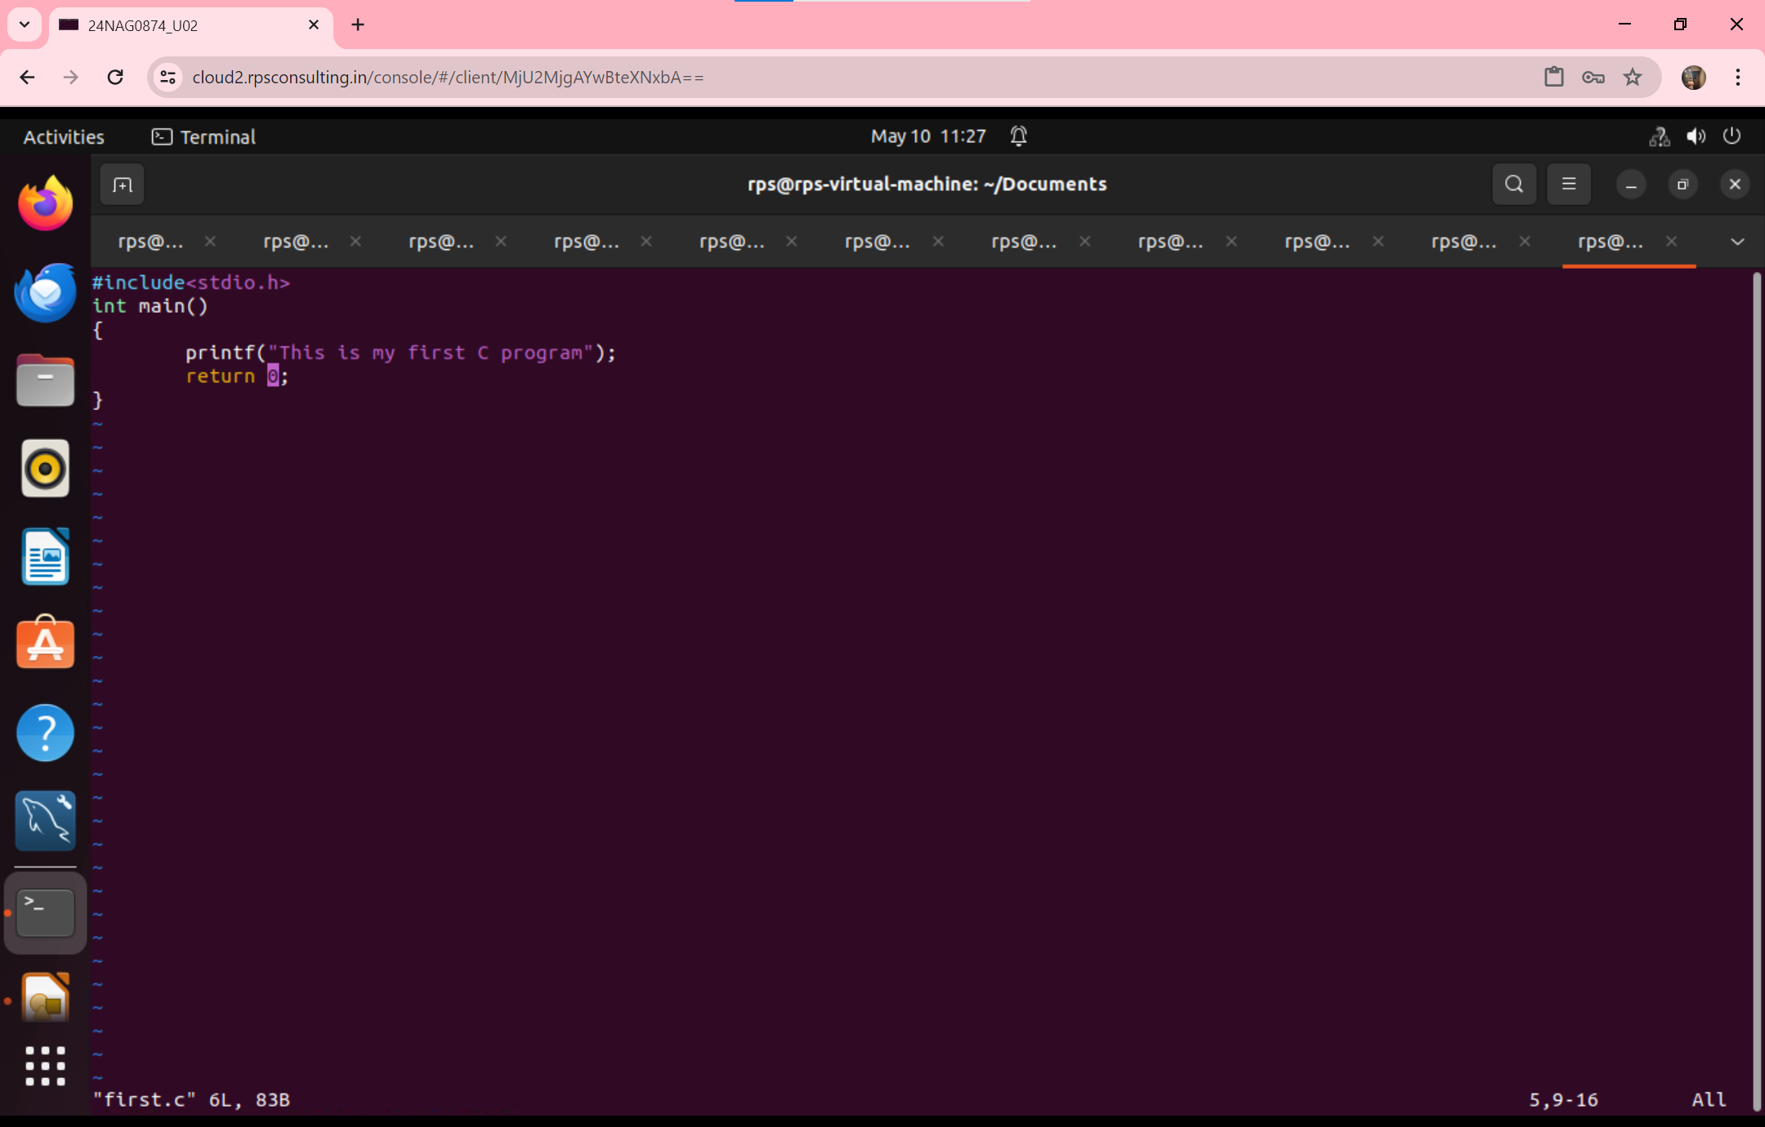

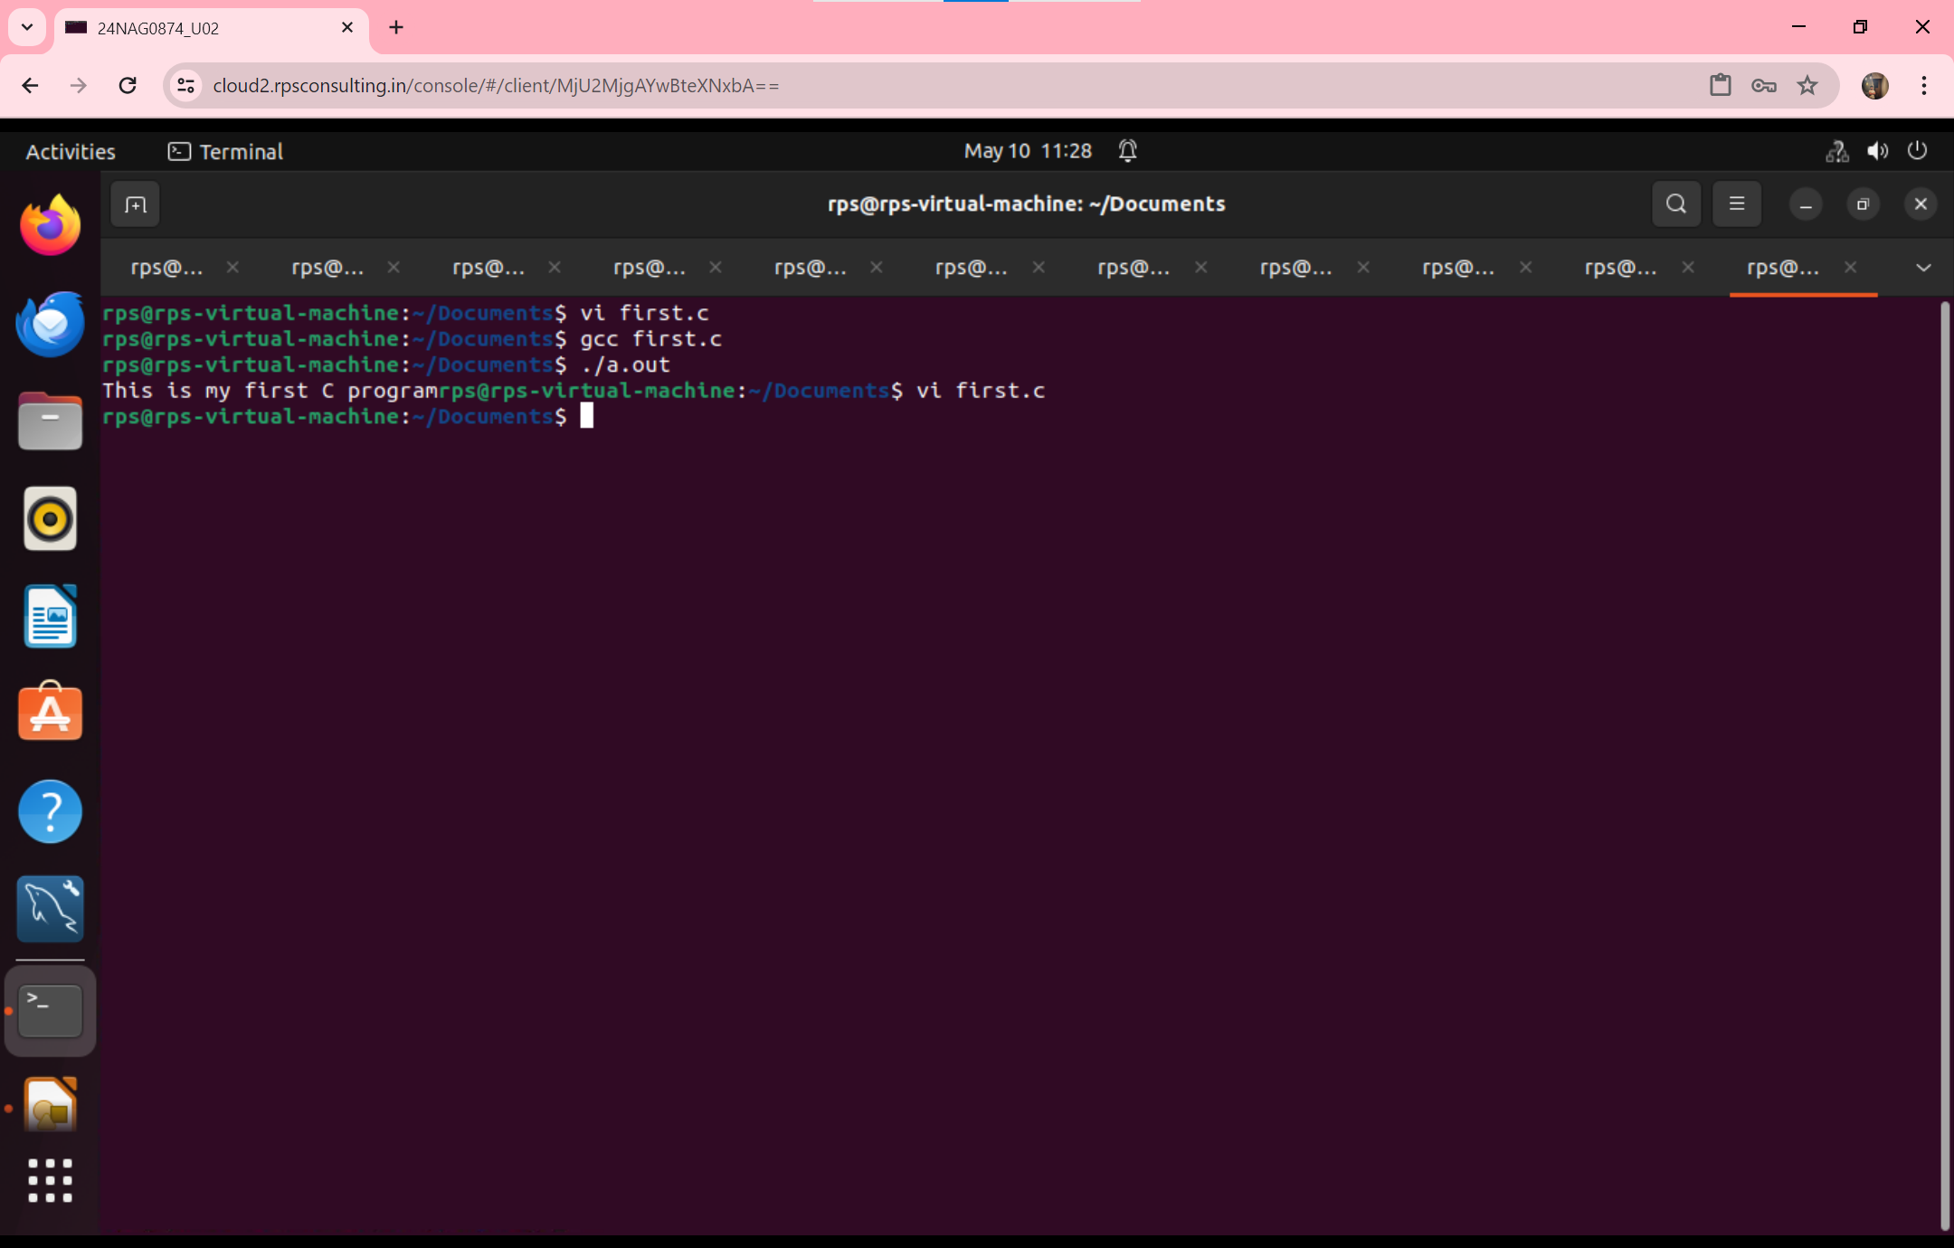

**QUESTION:2-Add two numbers**

**1)static input**

**2)dynamic input**

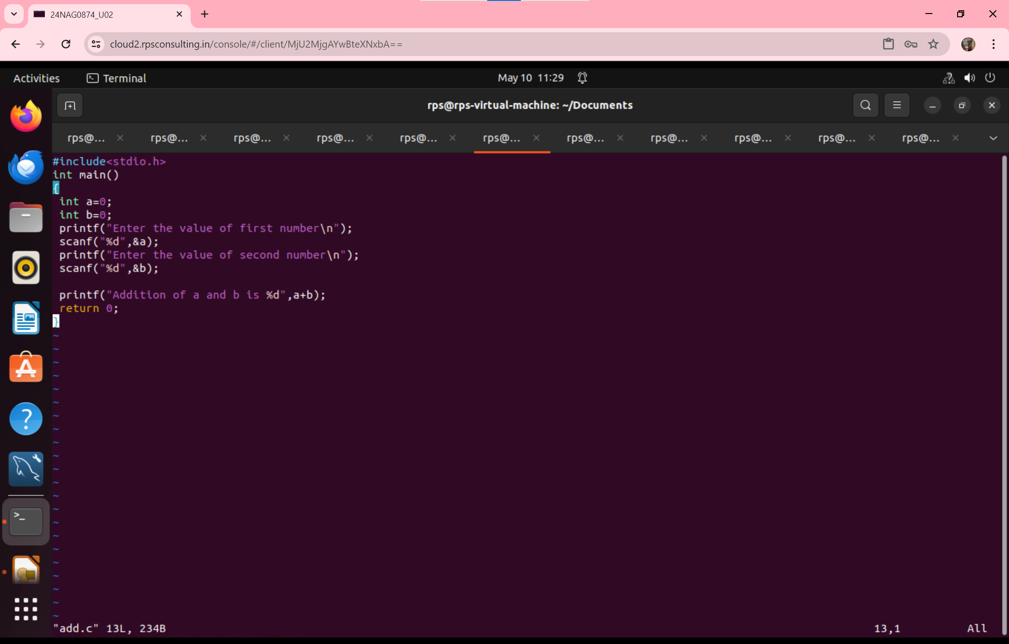

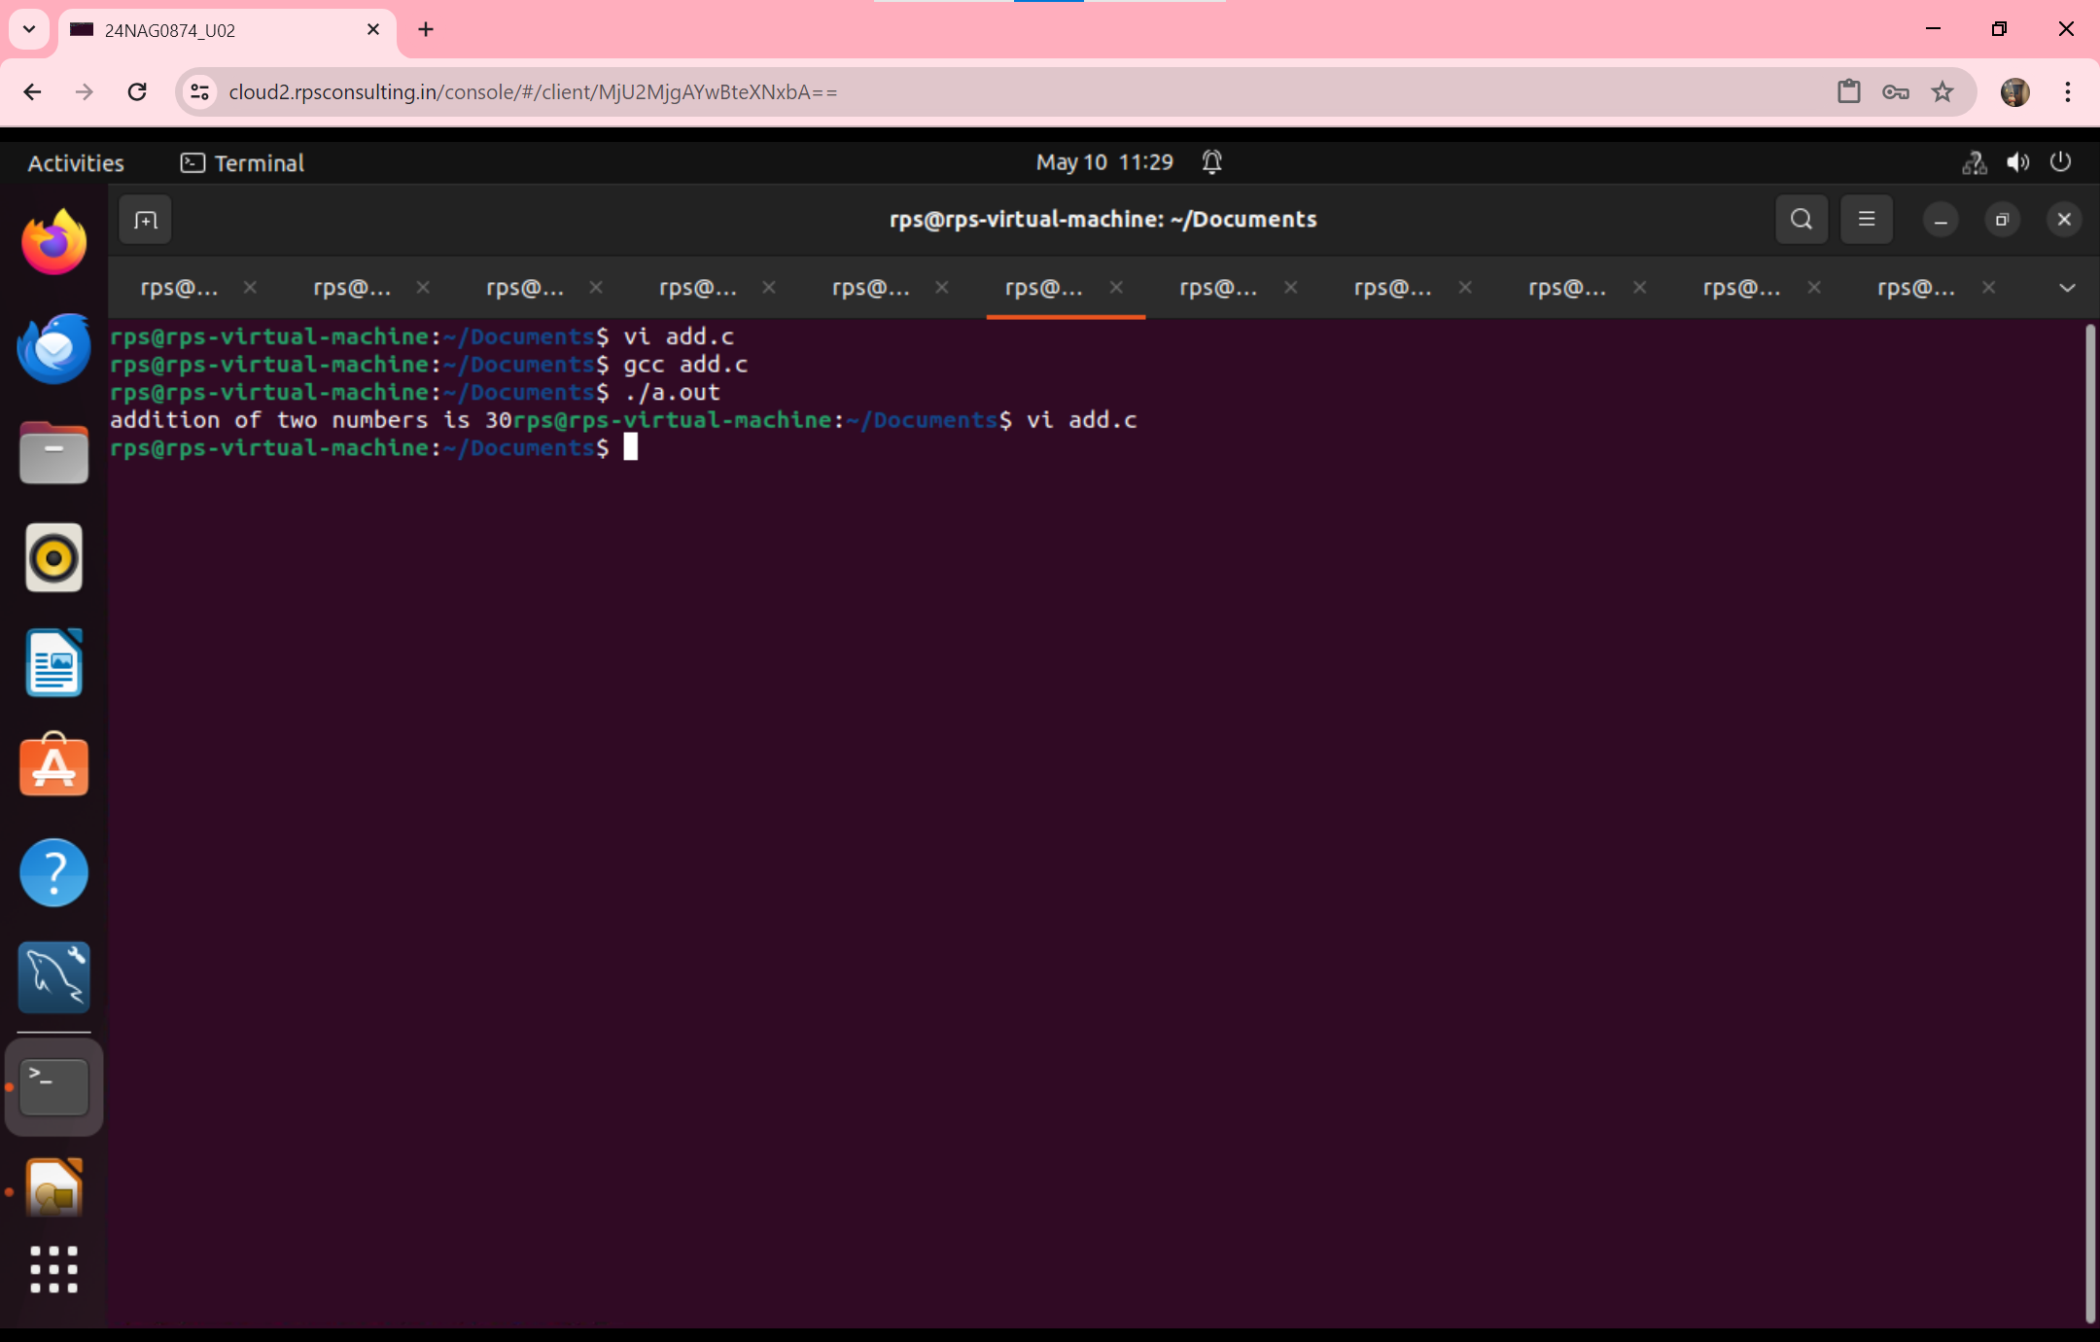

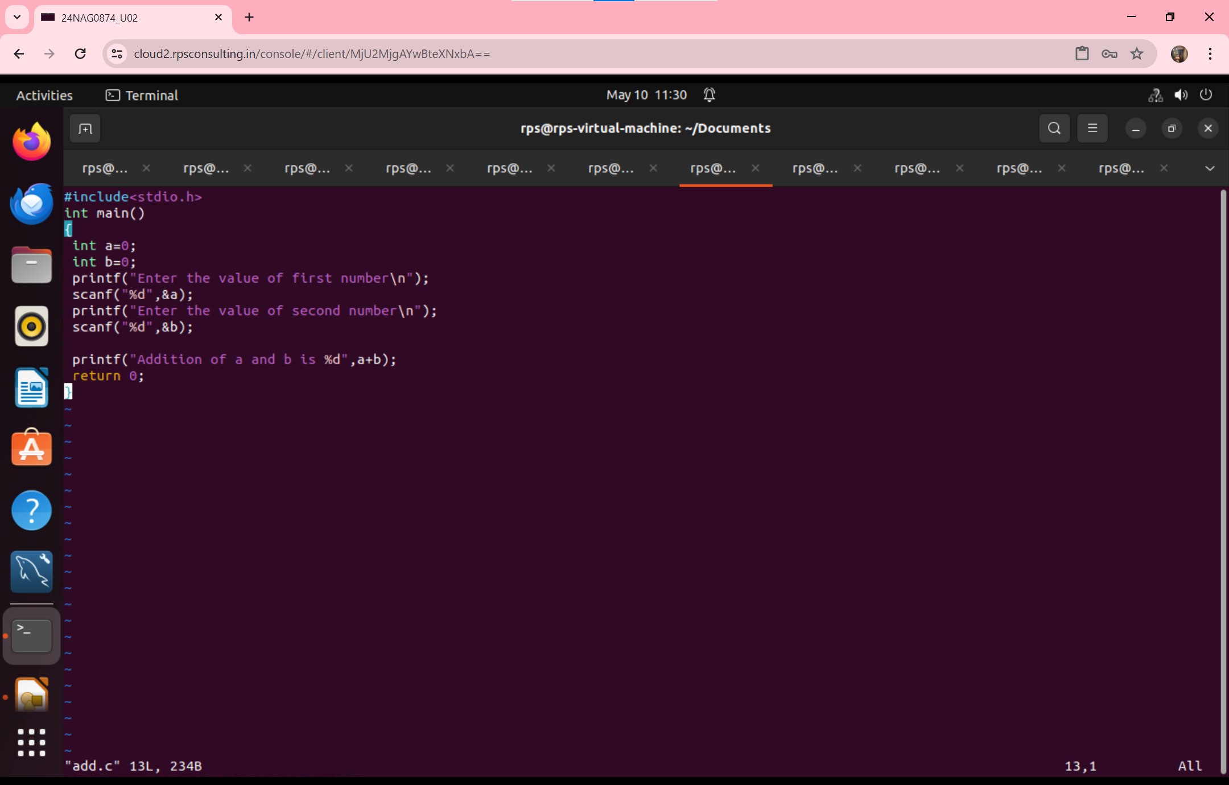

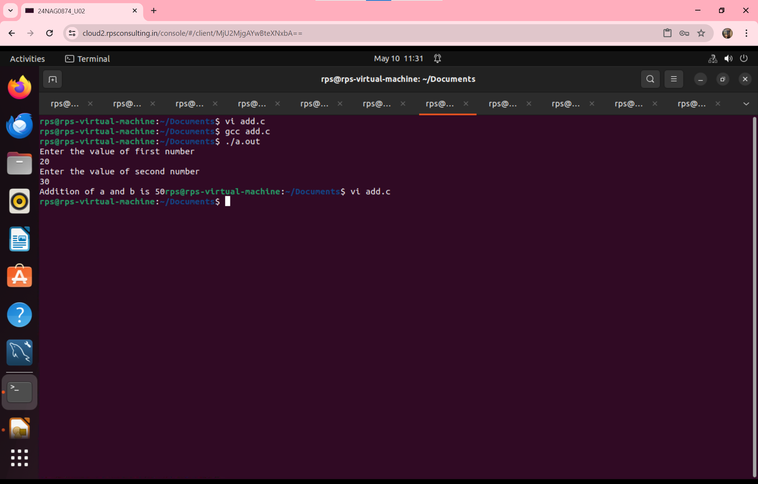

**QUESTION-3 –Write a program to print the Date and Time on the screen**

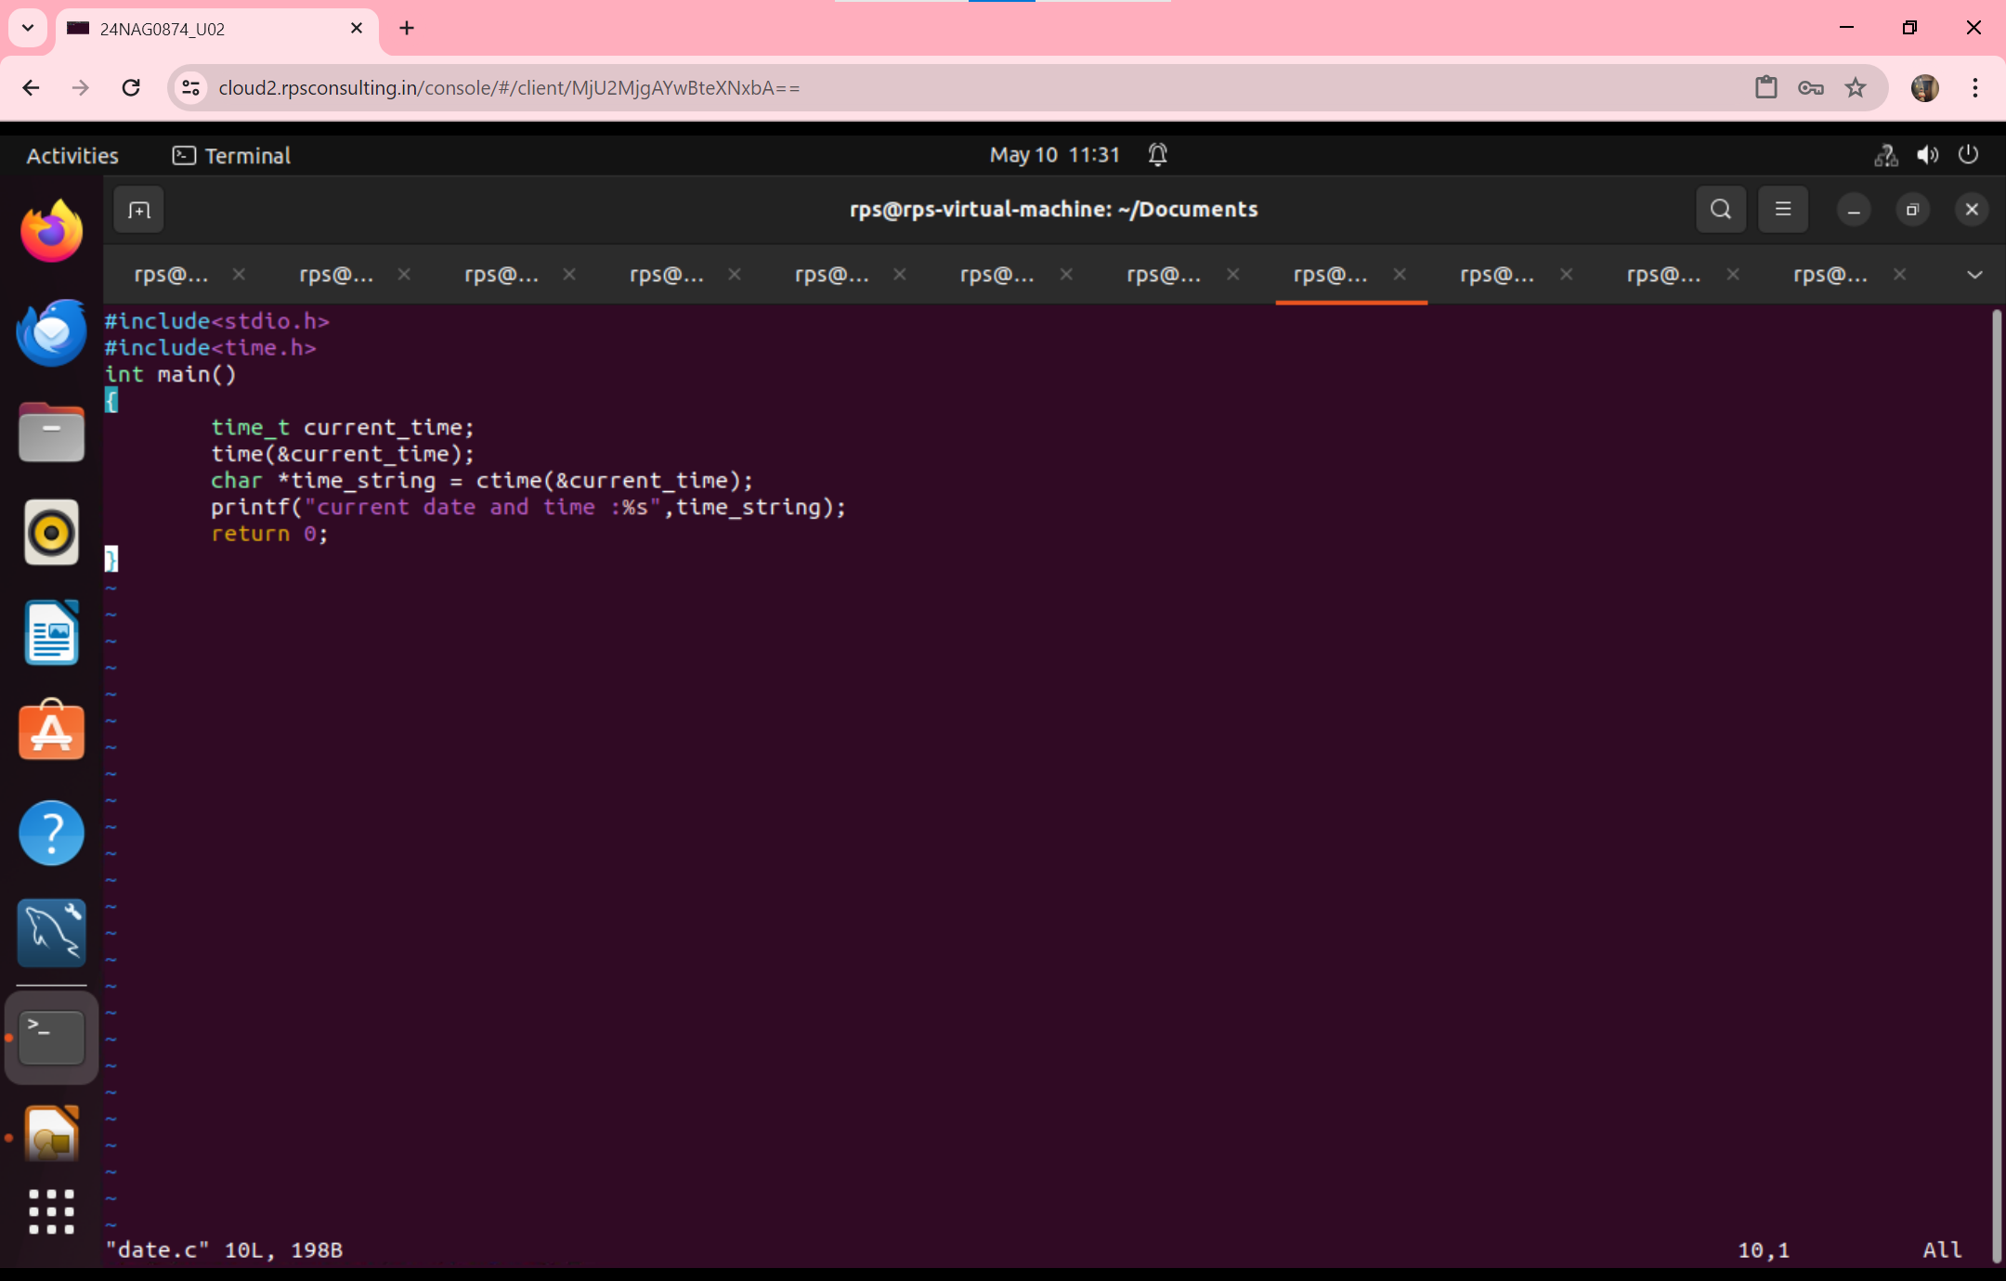

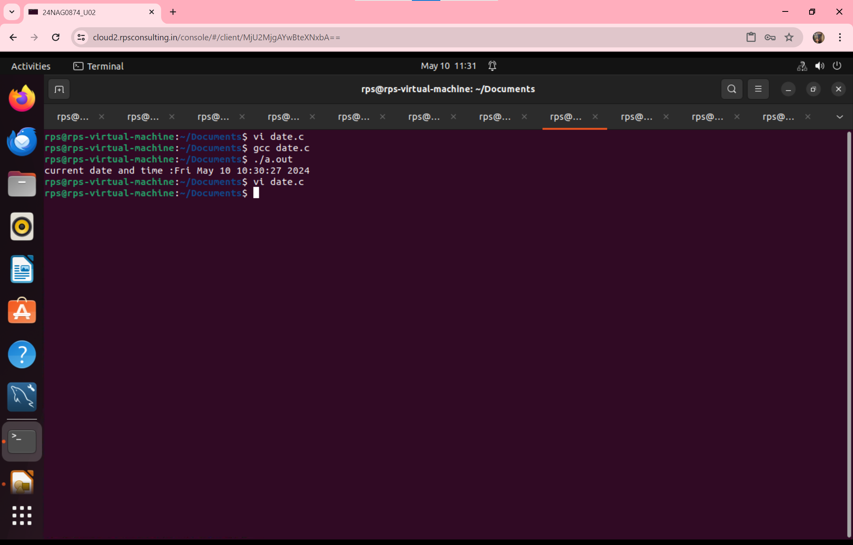

**QUESTION-4: Write a program to Take input from User to enter their name, and on the screen.**

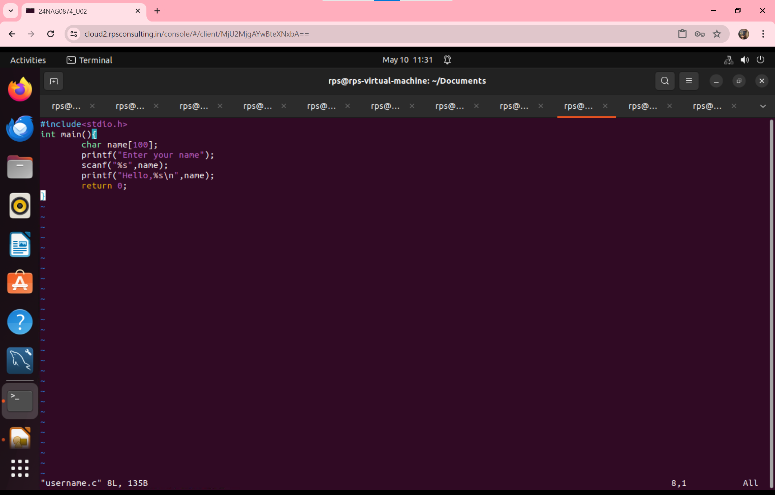

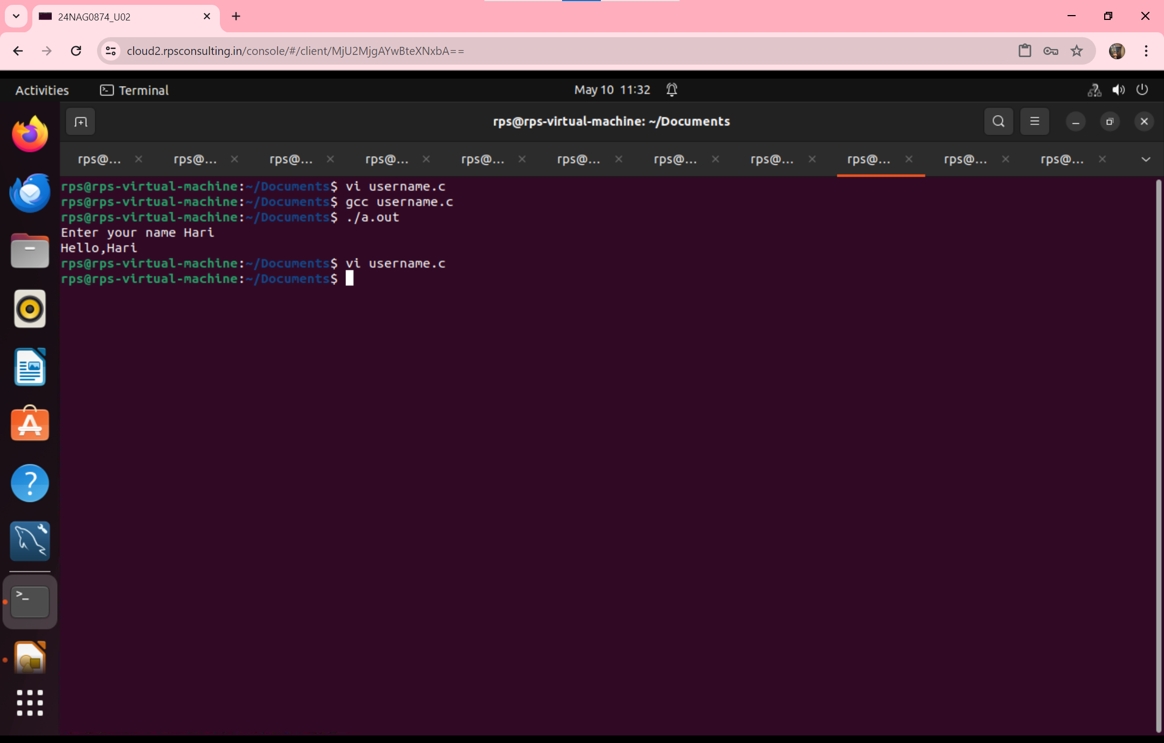

**QUESTION-5-Write a program to print Even or Odd number.**

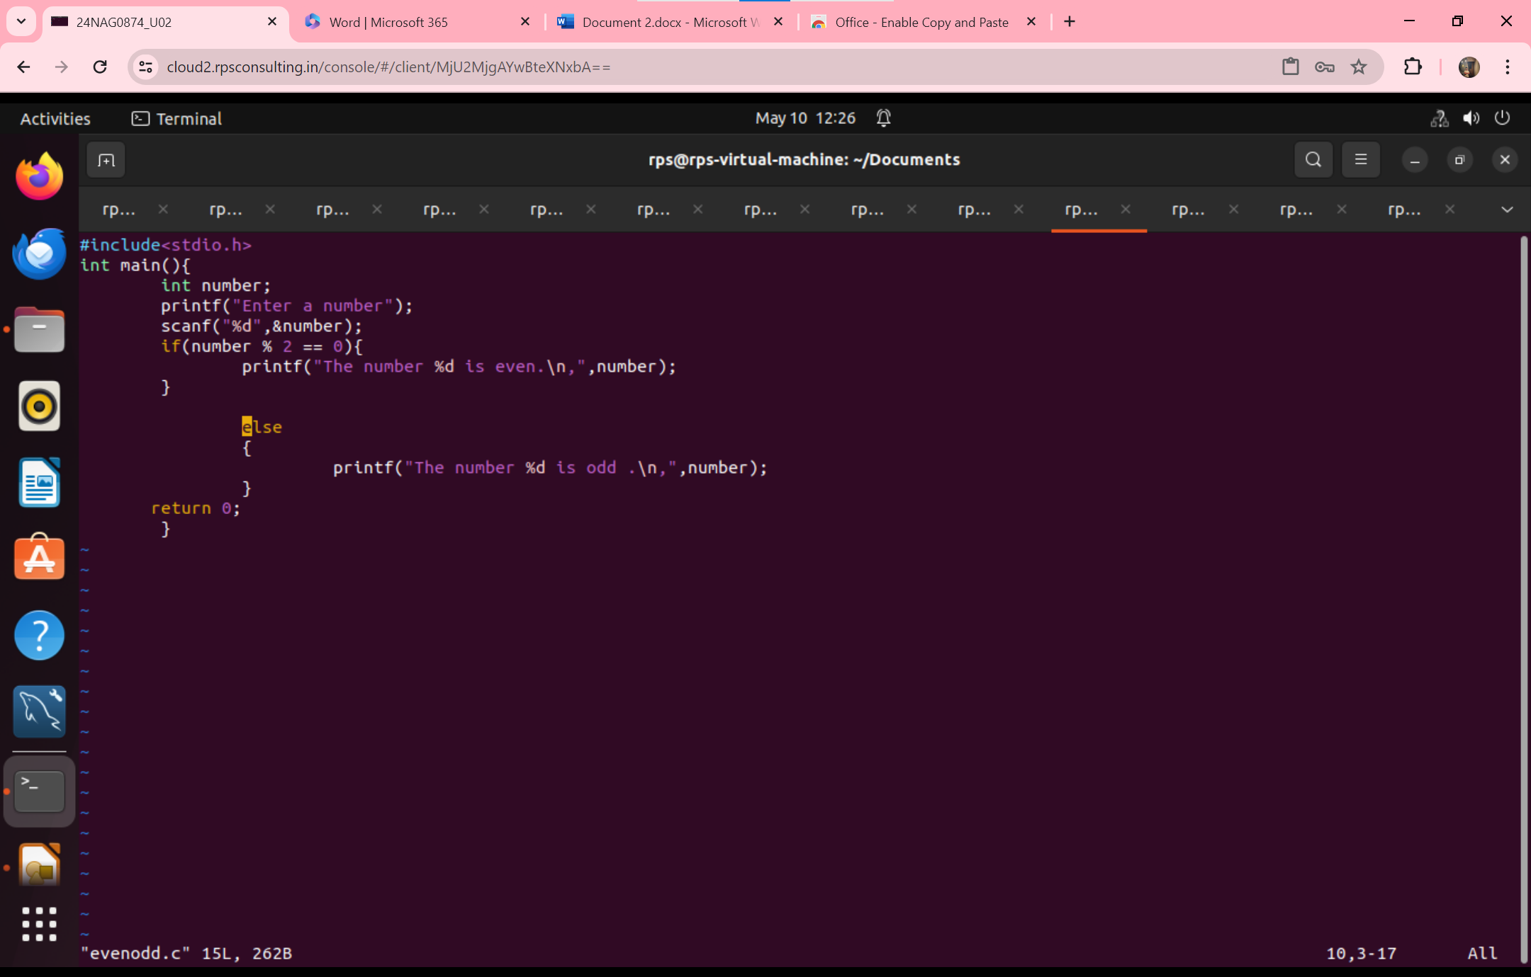

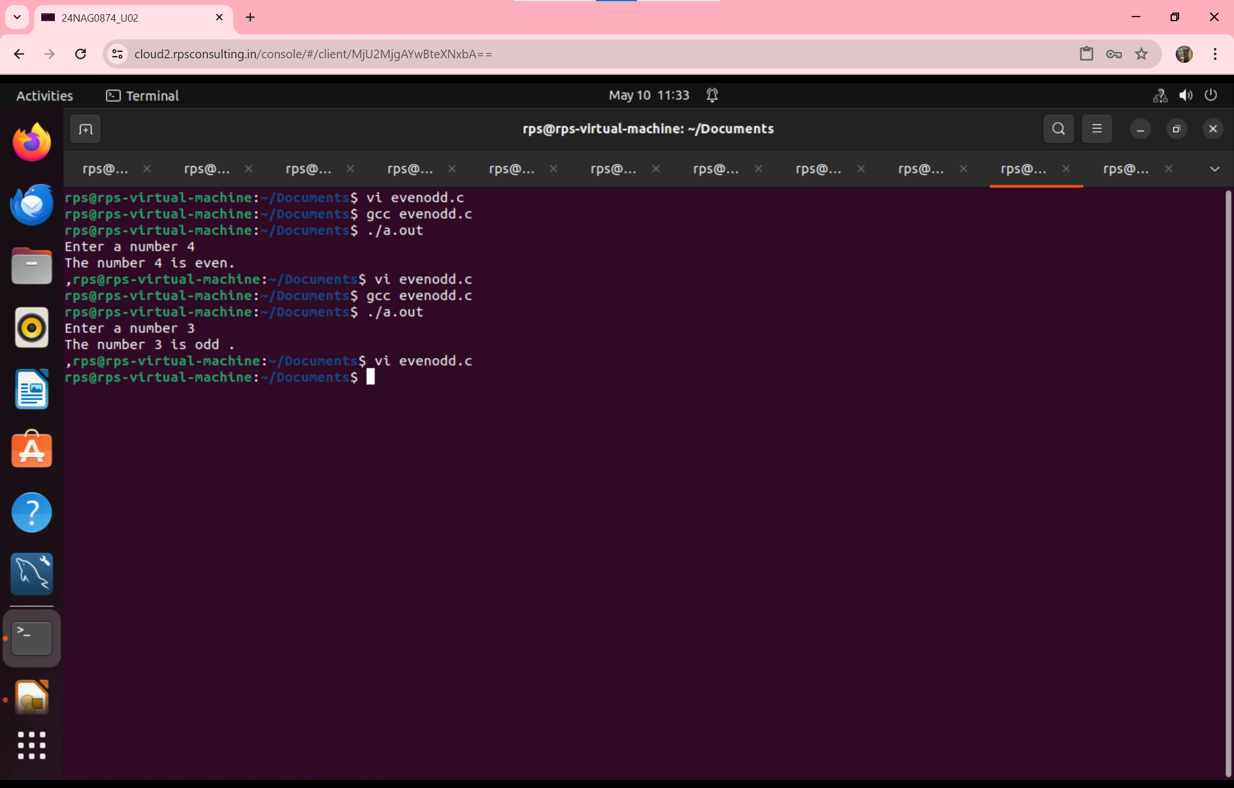

**QUESTION-6:Write a program to print the ASCII values by using Alphabets.**

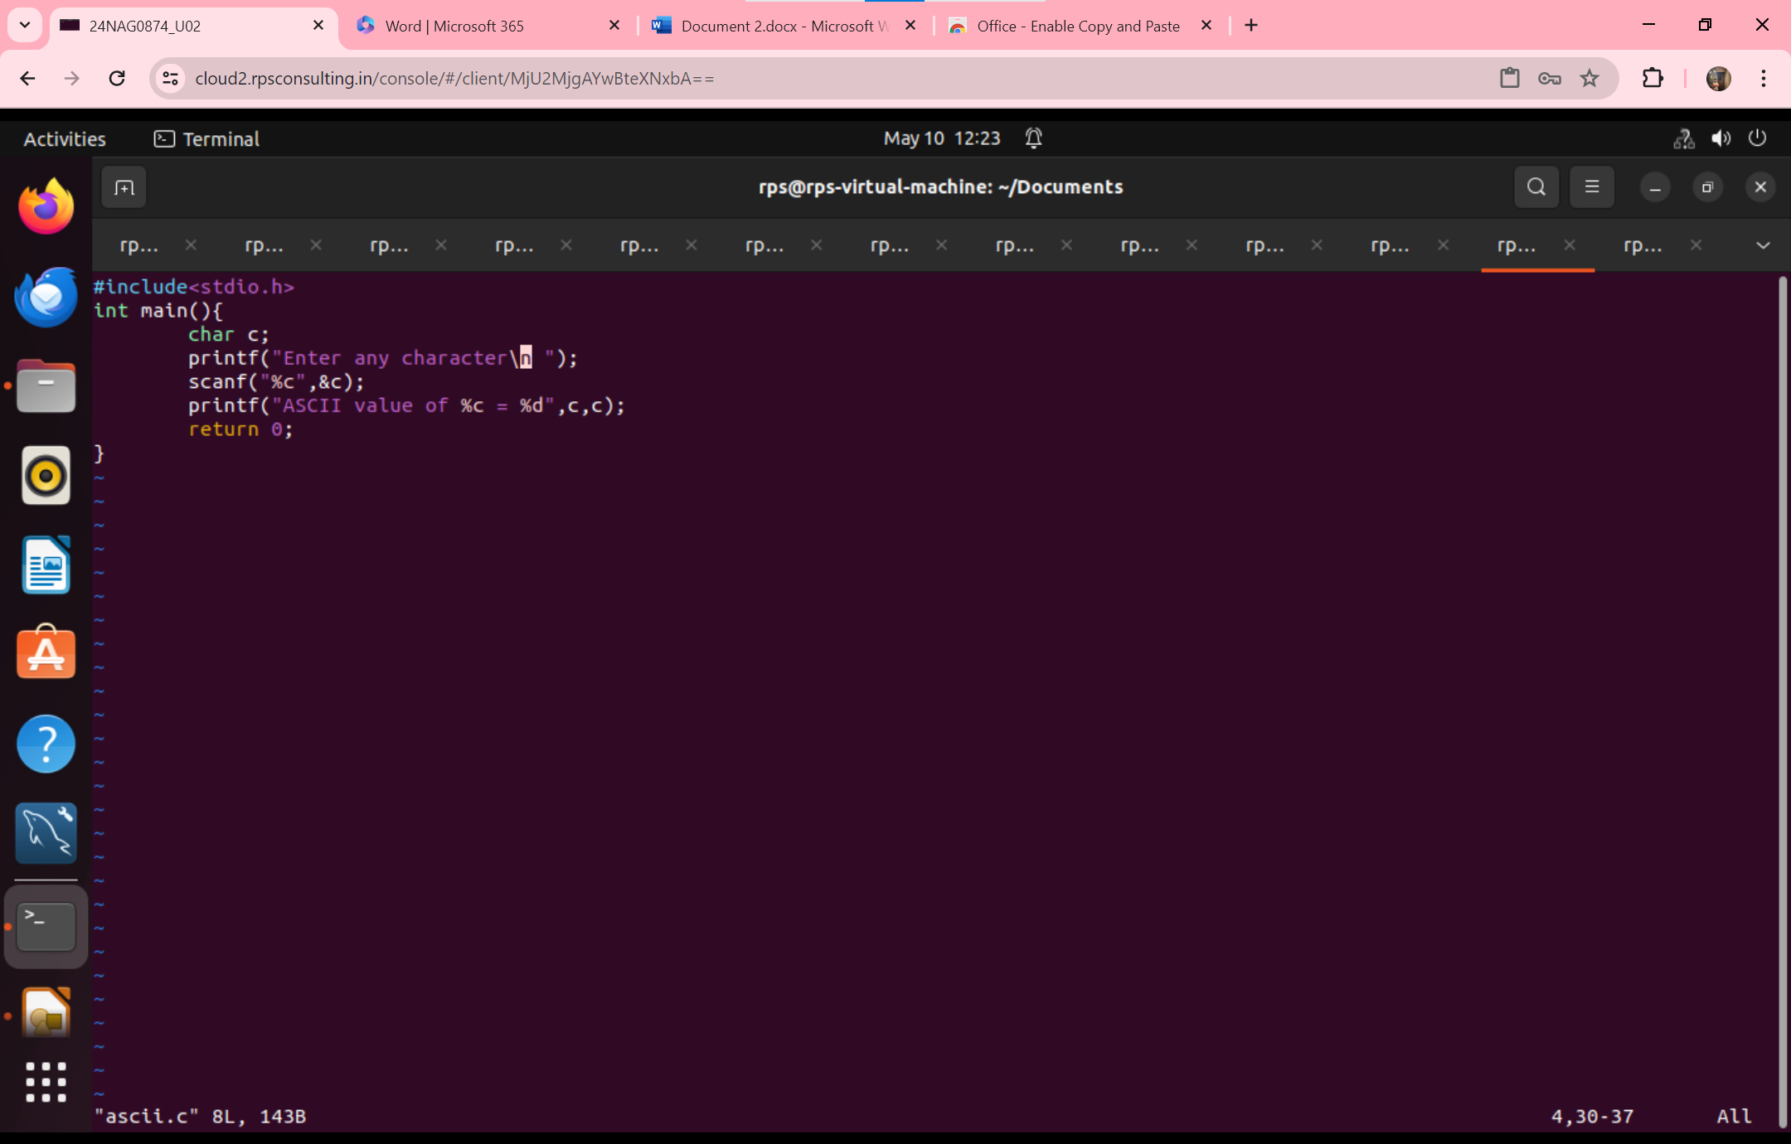

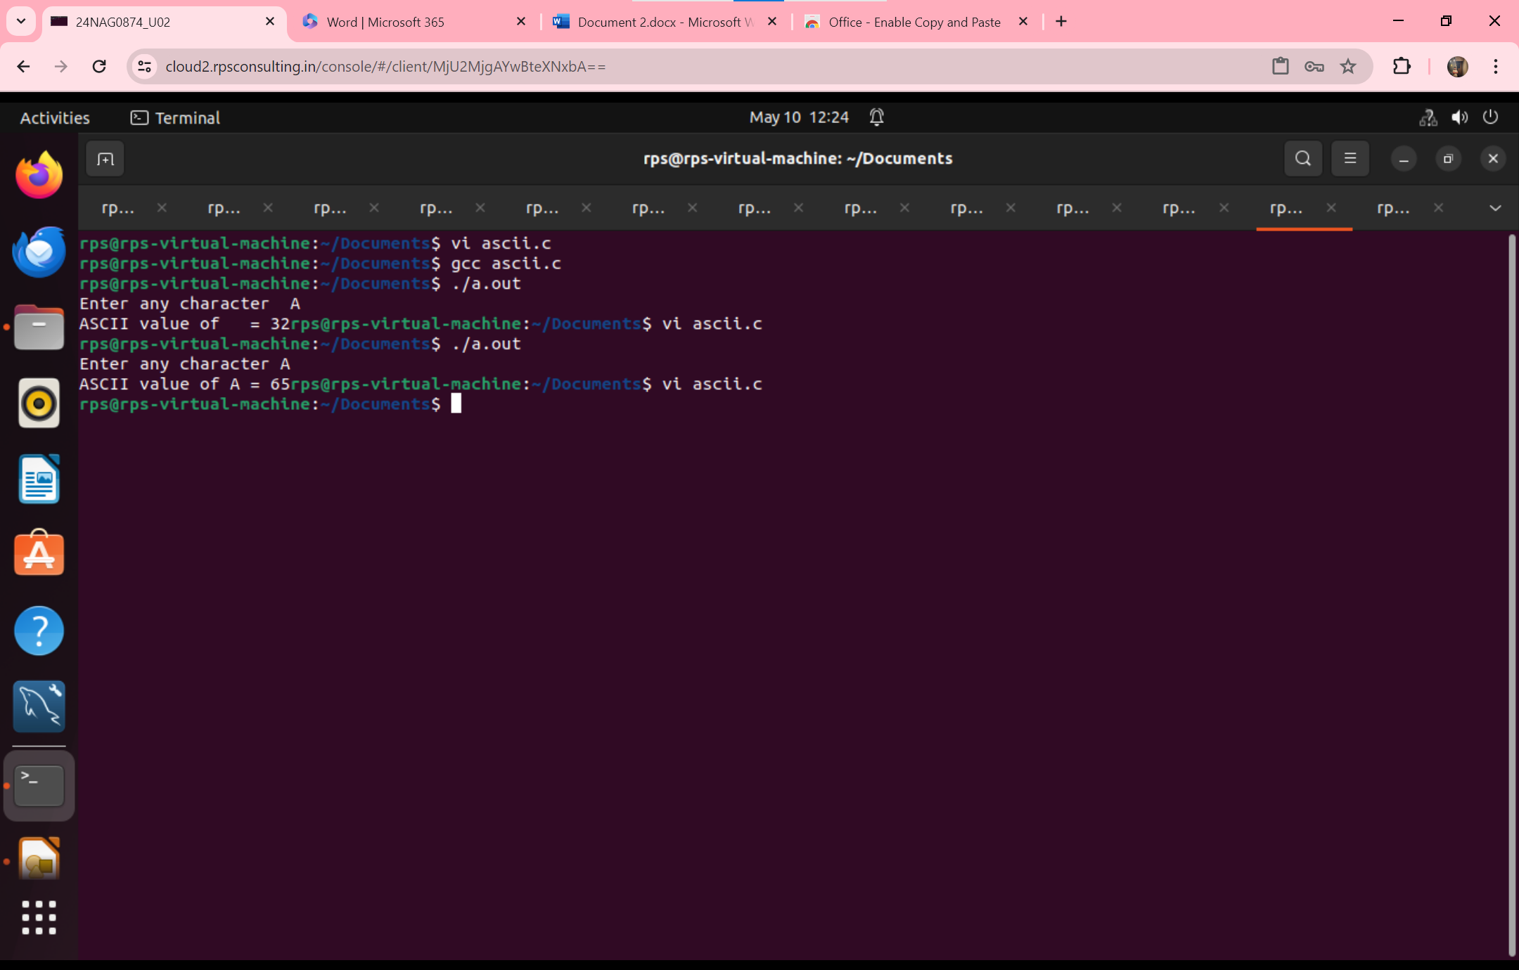

**QUESTION-7:Write a program to print the reverse number.**

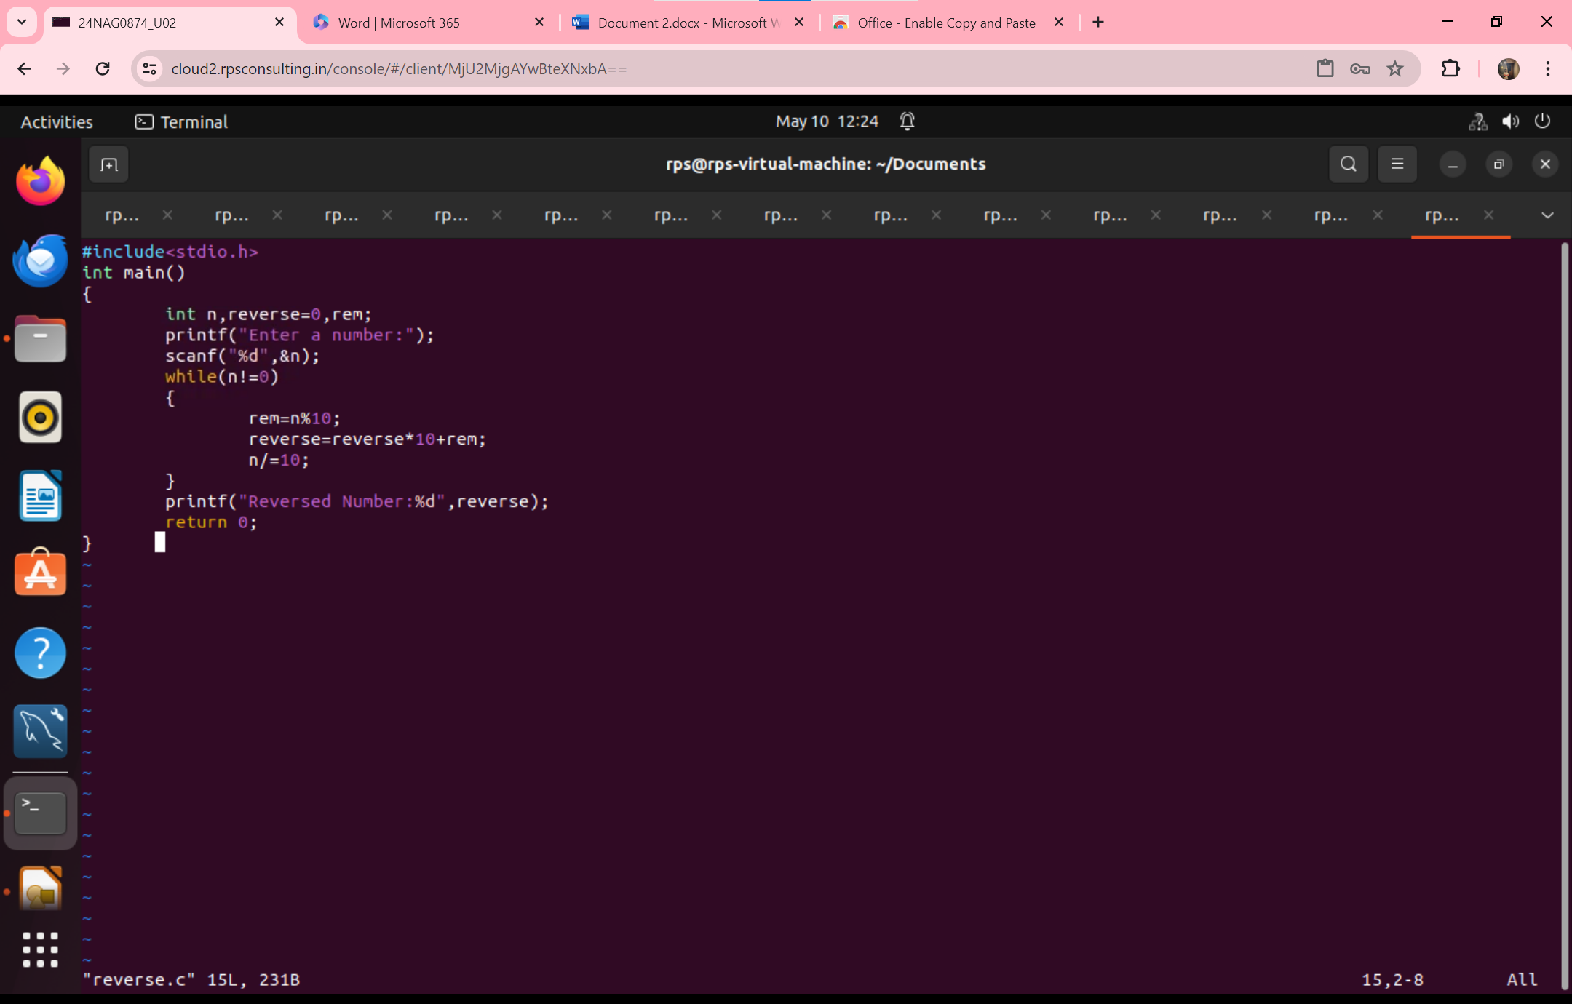

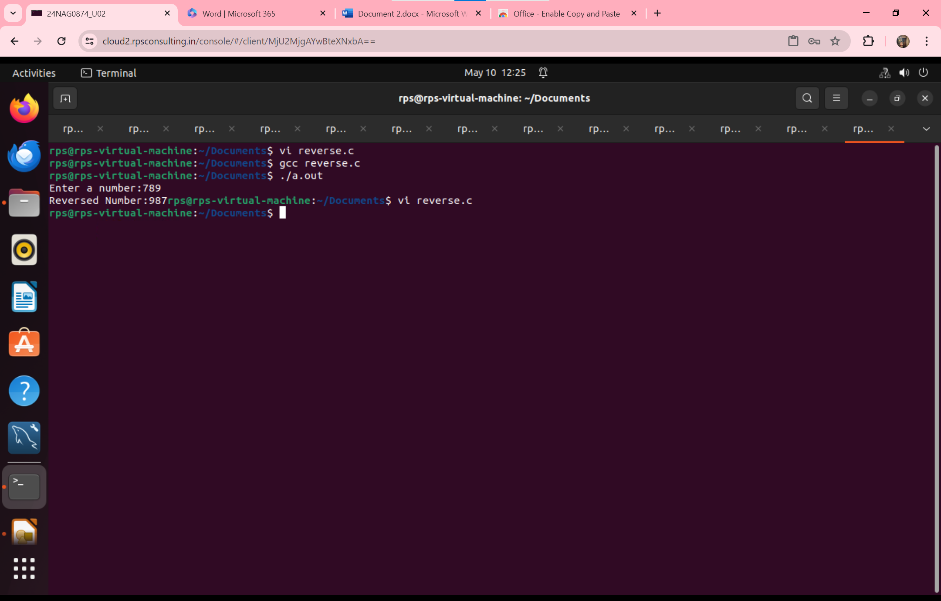

**QUESTION-8:Write a program to print the size of each datatype.**

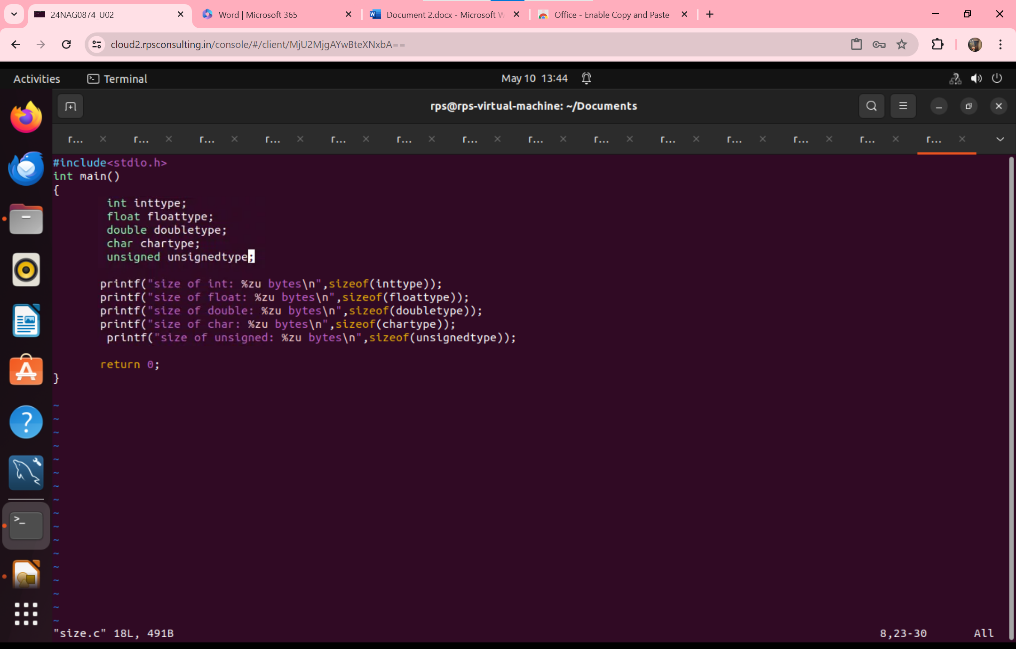

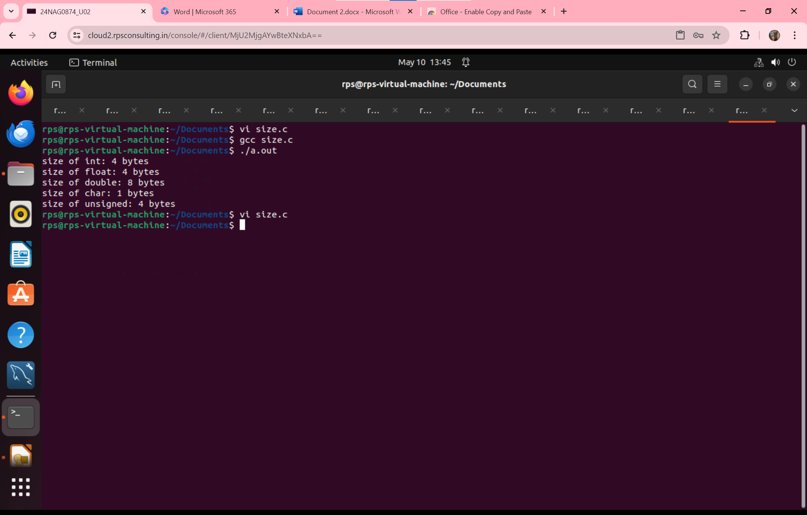

**Write a program to print Right half pyramid program.**

**Program:**

#include <stdio.h>

int main()

{

int rows, i, j;

printf("Enter the number of rows: ");

scanf("%d", &rows);

for (i = 1; i <= rows; i++)

{

for (j = 1; j <= i; j++)

{

printf("* ");

}

printf(" \n");

}

return 0;

}

**output:**

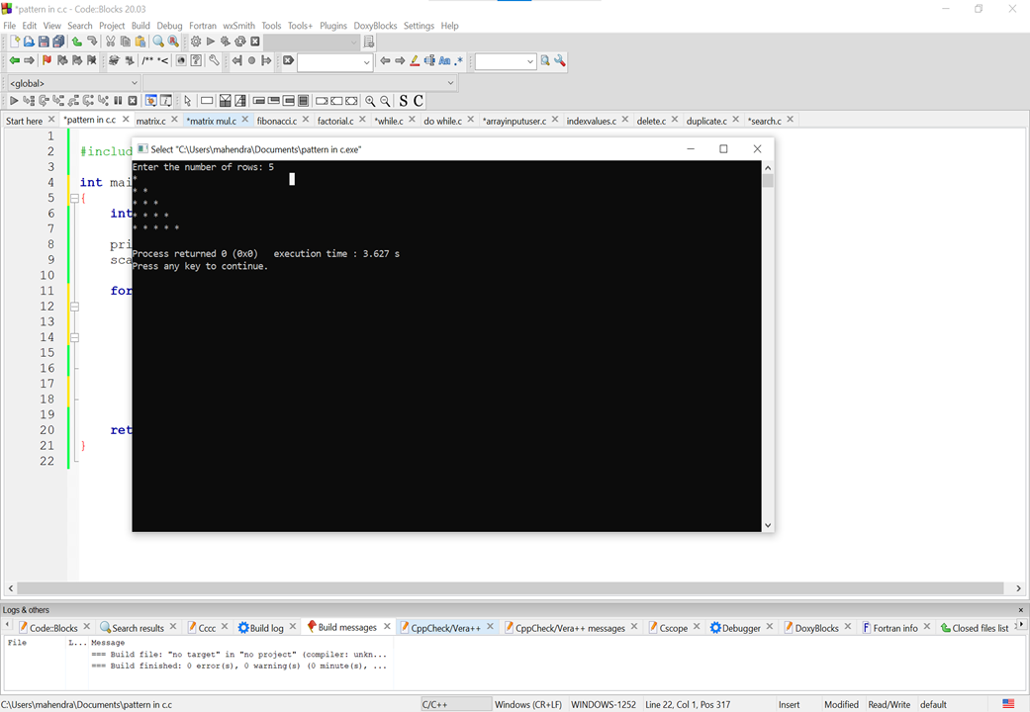

**Write program to print matrix multiplication in c**

**Program:**

#include<stdio.h>

#include<stdlib.h>

int main()

{

int a[5][5],b[5][5],mul[5][5],r,c,i,j,k;

system("cls");

printf("enter the number of row=");

scanf("%d",&r);

printf("enter the number of column=");

scanf("%d",&c);

printf("enter the first matrix element=\n");

for(i=0;i<r;i++)

{

for(j=0;j<c;j++)

{

scanf("%d",&a[i][j]);

}

}

printf("enter the second matrix element=\n");

for(i=0;i<r;i++)

{

for(j=0;j<c;j++)

{

scanf("%d",&b[i][j]);

}

}

printf("multiply of the matrix=\n");

for(i=0;i<r;i++)

{

for(j=0;j<c;j++)

{

mul[i][j]=0;

for(k=0;k<c;k++)

{

mul[i][j]+=a[i][k]*b[k][j];

}

}

}

for(i=0;i<r;i++)

{

for(j=0;j<c;j++)

{

printf("%d\t",mul[i][j]);

}

printf("\n");

}

return 0;

}

**Output:**

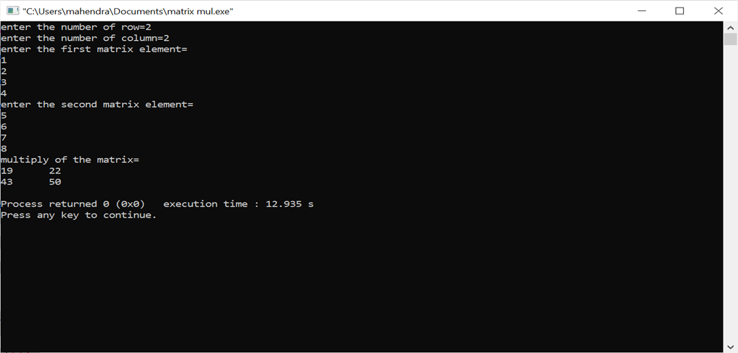

**write a program to print fibonacci series of a number.**

**Program:**

#include<stdio.h>

int main()

{

int n1=0,n2=1,n3,i,number;

printf("Enter the number of elements:");

scanf("%d",&number);

printf("\n%d %d",n1,n2);

for(i=2;i<number;++i)

{

n3=n1+n2;

printf(" %d",n3);

n1=n2;

n2=n3;

}

return 0;

}

**Output:**

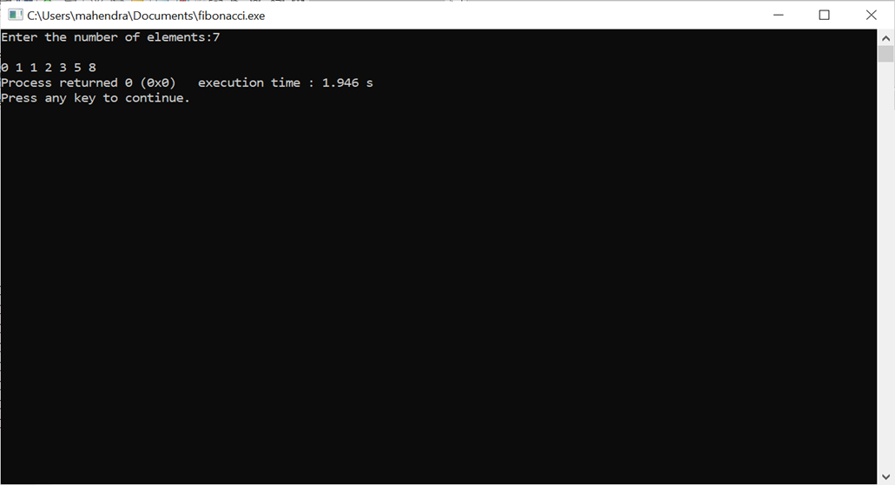

**write a program to print factorial of a number.**

**Program:**

#include<stdio.h>

int main()

{

int i,fact=1,number;

printf("Enter a number: ");

scanf("%d",&number);

for(i=1;i<=number;i++)

{

fact=fact*i;

if(i==1)

printf("%d",i);

else

printf("*%d\n",i);

}

printf("\n Factorial of %d is: %d\n",number,fact);

return 0;

}

**Output:**

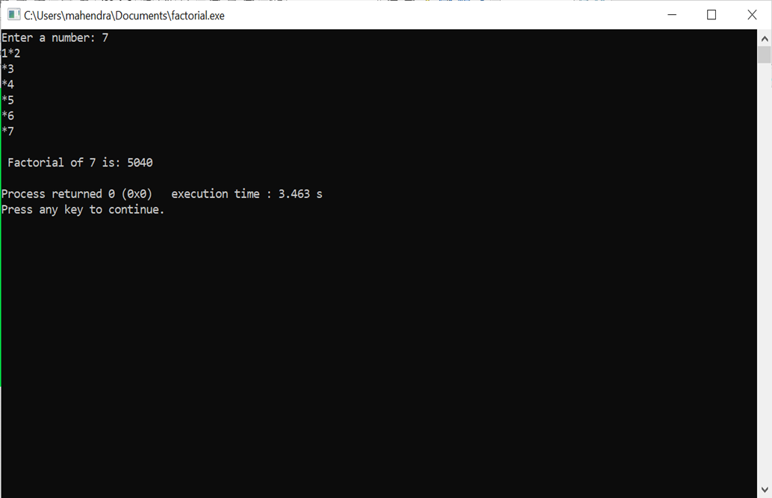

**Do while loop example:**

**Program:**

#include <stdio.h>

int main() {

int num, sum = 0;

do {

printf("Enter a number (enter a negative number to exit): ");

scanf("%d", &num);

if (num >= 0) {

sum += num;

}

} while (num >= 0);

printf("Sum of positive numbers entered: %d\n", sum);

return 0;

}

**Output:**

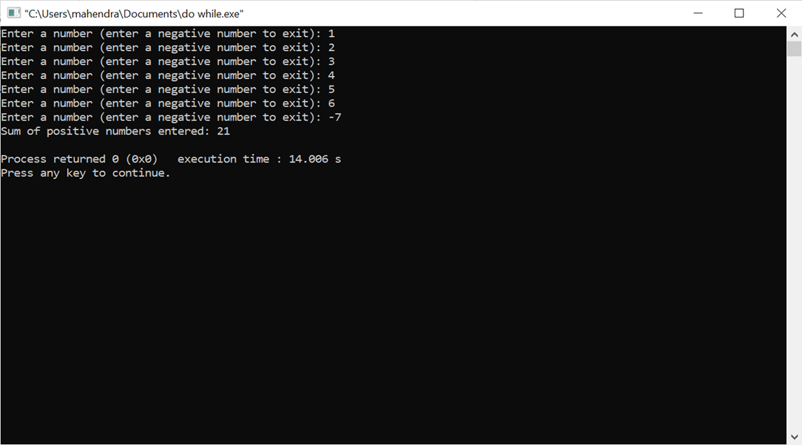

**write a program to print a[20] , take the input from user.**

**Program:**

#include <stdio.h>

int main() {

int a[20];

printf("Enter 20 integer values:\n");

for (int i = 0; i < 20; i++) {

printf("Enter element %d: ", i + 1);

scanf("%d", &a[i]);

}

printf("You entered:\n");

for (int i = 0; i < 20; i++) {

printf("%d ", a[i]);

}

printf("\n");

return 0;

}

**Output:**

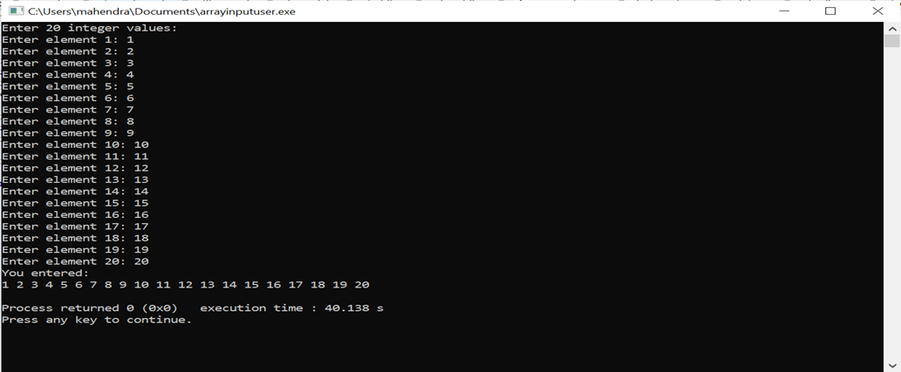

**write a program to print all the elements pf a[20] with their Index values**

**Program:**

#include <stdio.h>

int main() {

int a[20];

printf("Enter 20 integer values:\n");

for (int i = 0; i < 20; i++) {

printf("Enter element %d: ", i + 1);

scanf("%d", &a[i]);

}

printf("Index\tValue\n");

for (int i = 0; i < 20; i++) {

printf("%d\t%d\n", i, a[i]);

}

return 0;

}

**Output:**

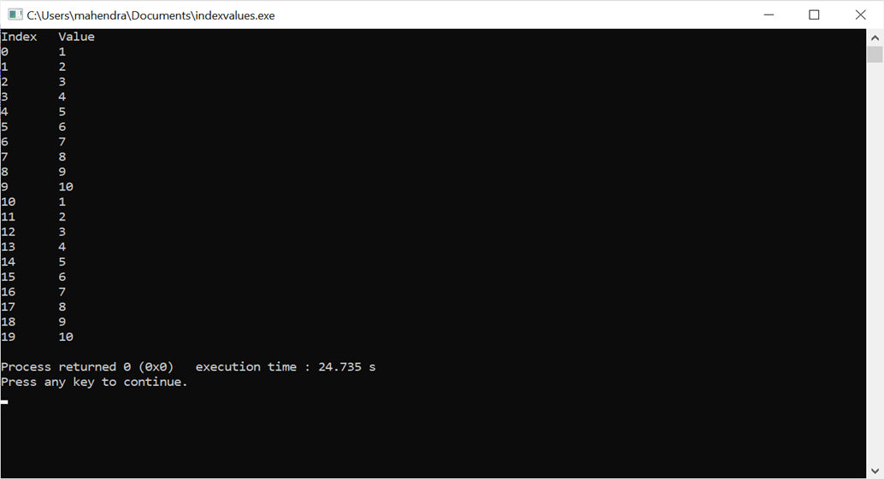

**write a program to print Delete a particular elemenet from an array, a[15]**

**Program:**

#include <stdio.h>

int main() {

int a[15] = {1, 2, 3, 4, 5, 6, 7, 8, 9, 10, 11, 12, 13, 14, 15};

int delete_index;

int i, j;

printf("Enter the index of the element you want to delete (0 to 14): ");

scanf("%d", &delete_index);

if (delete_index < 0 || delete_index >= 15) {

printf("Invalid index!\n");

return 1;

}

for (i = delete_index; i < 14; i++) {

a[i] = a[i + 1];

}

a[14] = 0;

printf("Array after deleting element at index %d:\n", delete_index);

for (i = 0; i < 15; i++) {

printf("%d ", a[i]);

}

return 0;

}

**Output:**

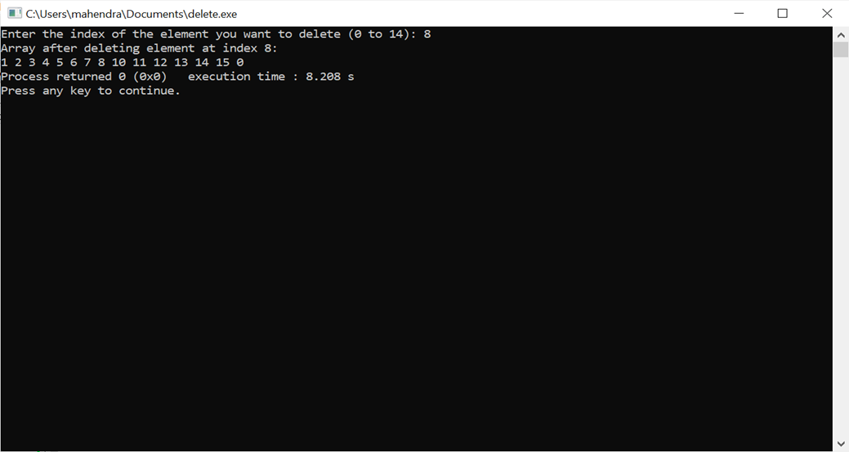

**write a program to print Find if there s any duplicates in a[20]**

**Program:**

#include <stdio.h>

int main() {

int a[20];

int i, j;

int found = 0;

printf("Enter 20 elements for the array:\n");

for (i = 0; i < 20; i++) {

scanf("%d", &a[i]);

}

for (i = 0; i < 20; i++) {

for (j = i + 1; j < 20; j++) {

if (a[i] == a[j]) {

found = 1;

printf("Duplicate found: %d\n", a[i]);

}

}

}

if (!found) {

printf("No duplicates found.\n");

}

return 0;

}

**Output:**

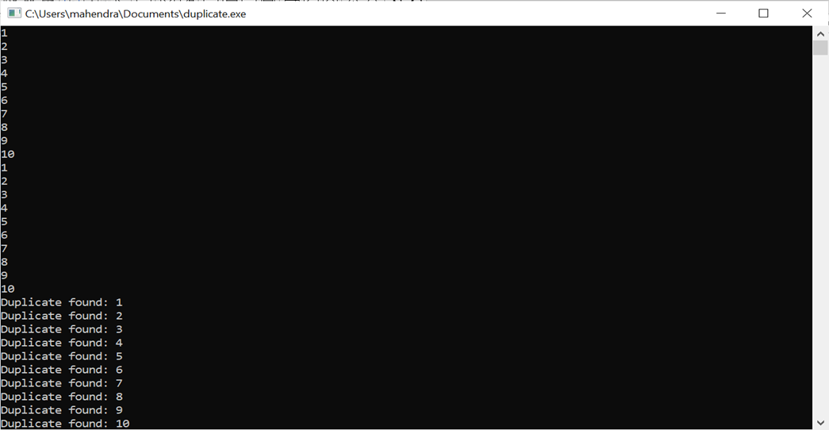

**write a program to print search [10] from a[20].**

**Program:**

#include <stdio.h>

}

for (i = 0; i < 20; i++) {

if (a[i] == search_value) {

found = 1;

printf("Value %d found at index %d.\n", search_value, i);

break;

}

}

if (!found) {

printf("Value %d not found in the array.\n", search_value);

}

return 0;

}

**Output:**

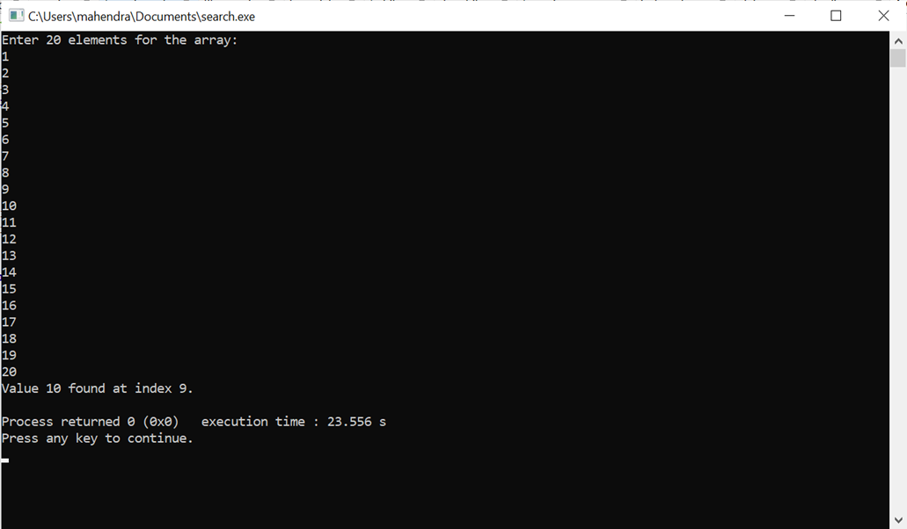

**Write a program on sum of pointers.**

**Program:**

#include <stdio.h>

float avg (int arr[], int size);

main ()

{

int x[100], k, n;

printf("\n Enter the array size :\n");

scanf ("%d",&n);

printf("\n Enter the array elements :\n");

for (k=0;k<n;k++)

{

scanf("%d", &x[k]);

}

printf("\n Average is : %f", avg (x,n));

}

float avg (int arr[], int size)

{

int *p,i,sum=0;

p=arr;

for (i=0;i<size;i++)

{

sum = sum + *(p+i);

}

return (float) sum/size;

}

**Output:**

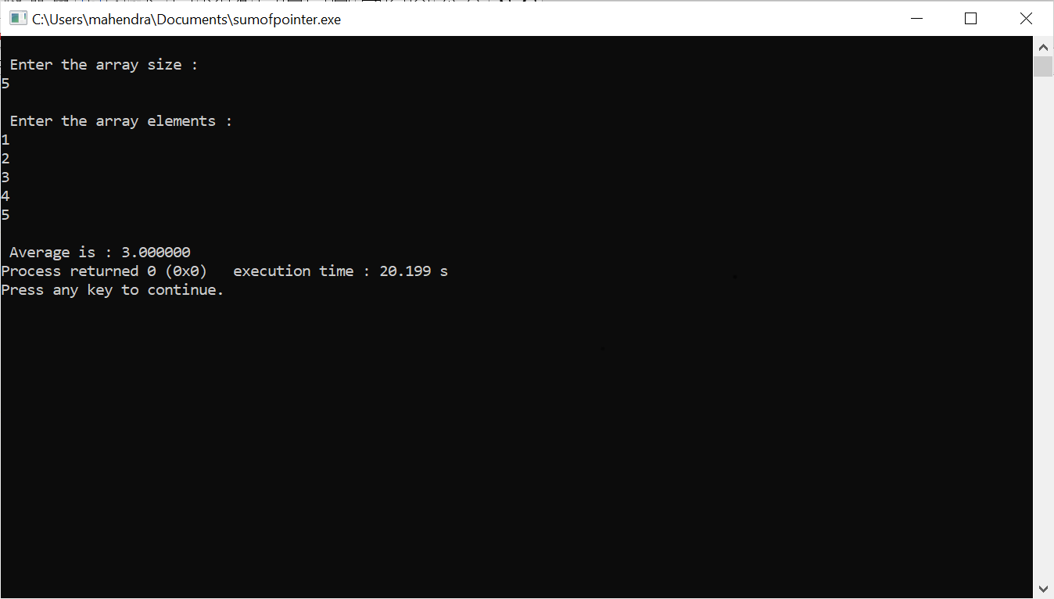

**Write a program on Assign the address of a pointer.**

**Program:**

#include <stdio.h>

int main() {

int *p, n;

// Assign the address of n to p

p = &n;

// Assign hexadecimal value 0x18 to n

n = 0x18;

// Increment the value pointed to by p by 4

*p = *p + 4;

// Assign the value pointed to by p plus 4 to n

n = *p + 4;

// Print the values

printf("Value of n: %d\n", n);

printf("Value pointed to by p: %d\n", *p);

getch();

}

**Output:**

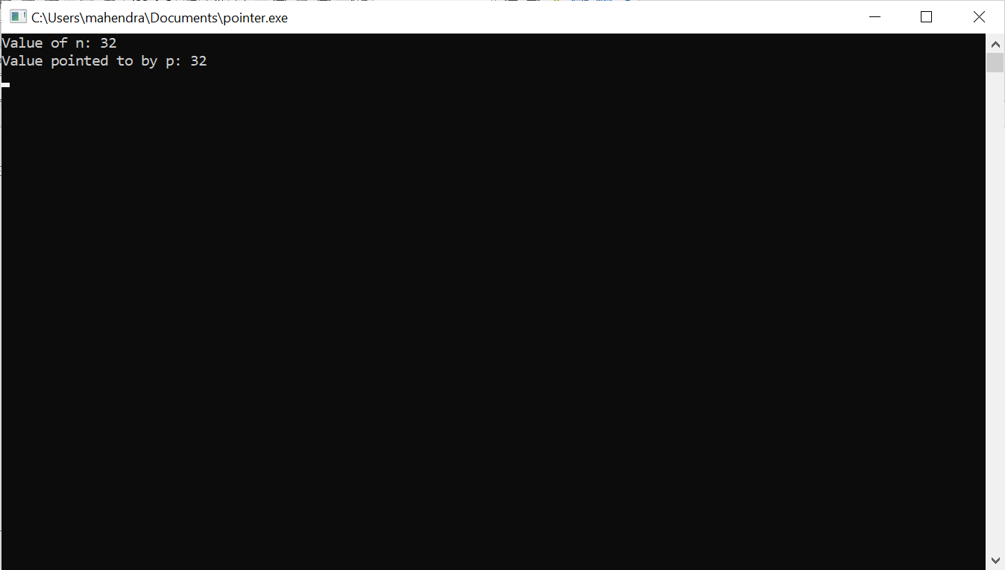

**Write a program to print size of Data Types.**

**Program:**

#include <stdio.h>

#include <conio.h>

main()

{

printf ("No. of Bytes occupied by int is %d \n", sizeof(int));

printf ("No. of Bytes occupied by float is %d \n", sizeof(float));

printf ("No. of Bytes occupied by double is %d \n", sizeof(double));

printf ("No. of Bytes occupied by char is %d \n", sizeof(char));

printf ("No. of Bytes occupied by long double is %d \n", sizeof(long double));

getch();

}

**Output:**

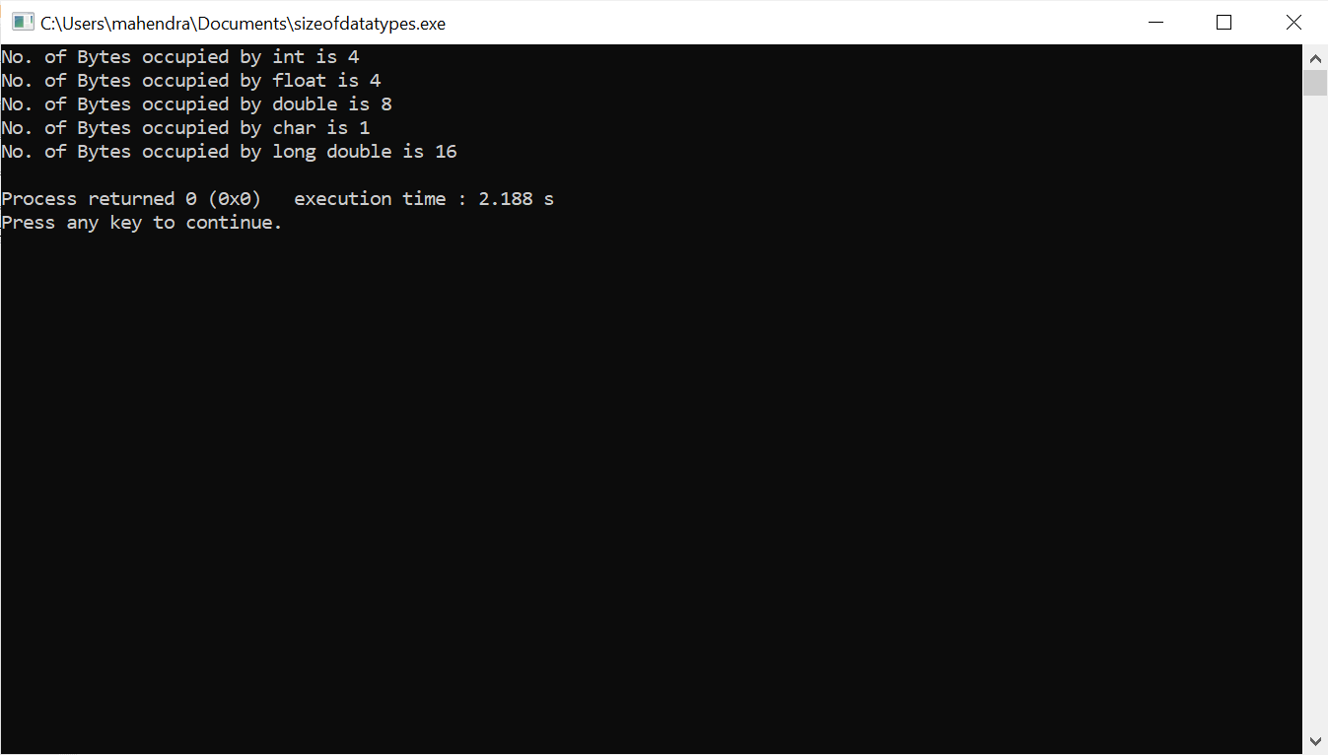

**Write a program on call by value and call by reference.**

**Program:**

#include <stdio.h>

main()

{

int a,b;

a=5, b=20;

swap (a,b);

swap1 (&a, &b);

// printf ("\n Swap Fun: (call by value) \n a = %d , b = %d ", a,b);

printf ("\n Swap1 Fun: (call by Ref) \n a = %d , b = %d ", a,b);

}

void swap (int x, int y)

{

int tmp;

tmp = x;

x=y;

y=tmp;

}

void swap1 (int *x1, int *y1)

{

int tmp1;

tmp1 = *x1;

*x1=*y1;

*y1=tmp1;

}

**Output:**

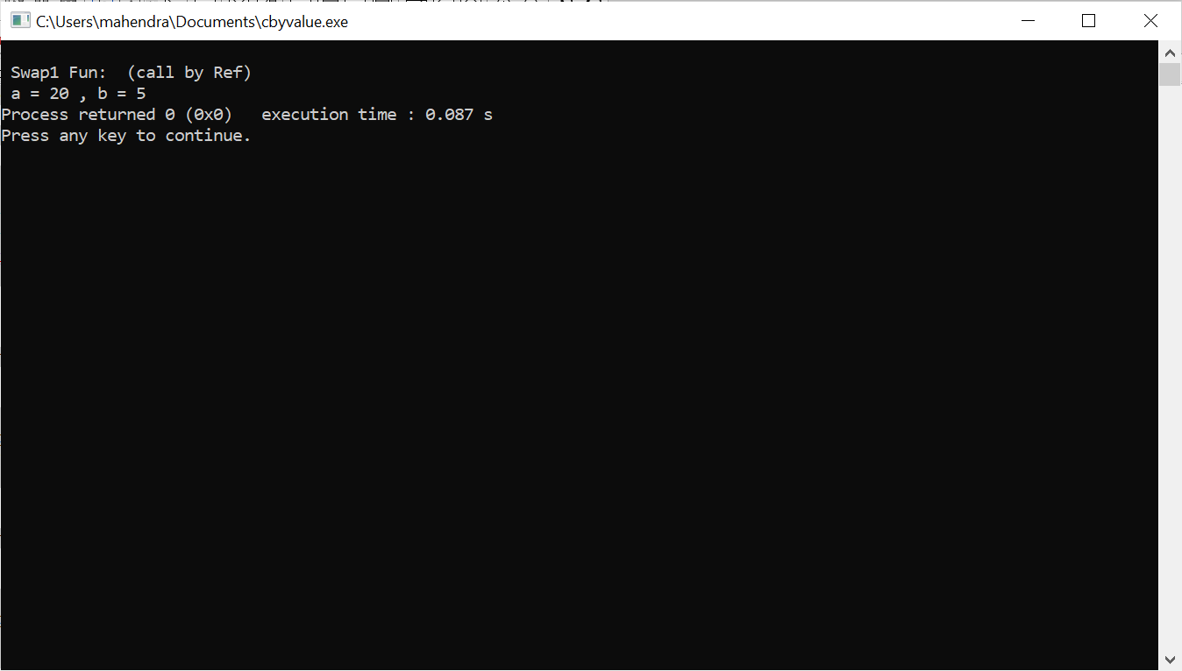

**Write a program on address of pointer.**

**Program:**

#include <stdio.h>

int main() {

int x = 10;

int *ptr;

int y;

ptr = &x;

y = *ptr;

printf("Value of x: %d\n", x);

printf("Address of x: %p\n", (void*)&x);

printf("Value pointed to by *&x: %d\n", *&x);

printf("Address of &x: %p\n", (void*)(&x));

printf("Value pointed to by *ptr: %d\n", *ptr);

printf("Value of ptr: %p\n", (void*)ptr);

printf("Value of y: %d\n", y);

printf("Address of &*ptr: %p\n", (void*)&(*ptr));

printf("Address of ptr: %p\n", (void*)&ptr);

getch();

}

**Output:**

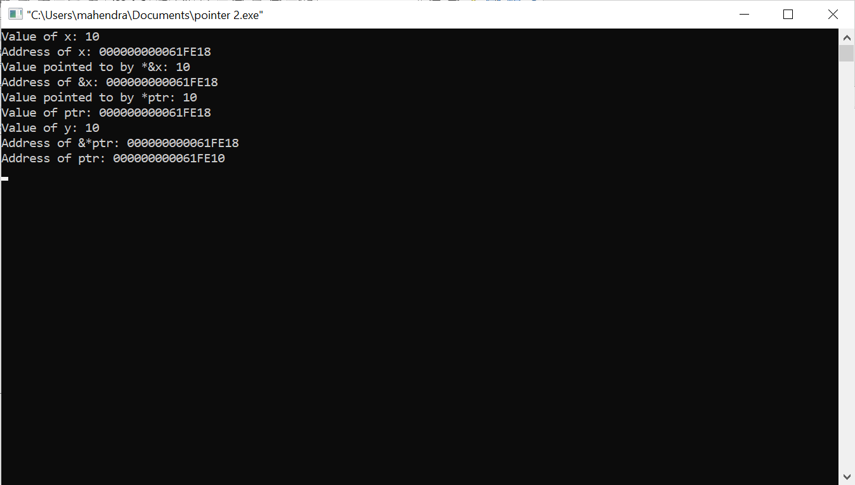

**Write a progrm on array to give input manually by the user.**

**Program:**

#include <stdio.h>

int main() {

int a[20];

printf("Enter 20 integer values:\n");

for (int i = 0; i < 20; i++) {

printf("Enter element %d: ", i + 1);

scanf("%d", &a[i]);

}

printf("You entered:\n");

for (int i = 0; i < 20; i++) {

printf("%d ", a[i]);

}

printf("\n");

return 0;

}

**Output:**

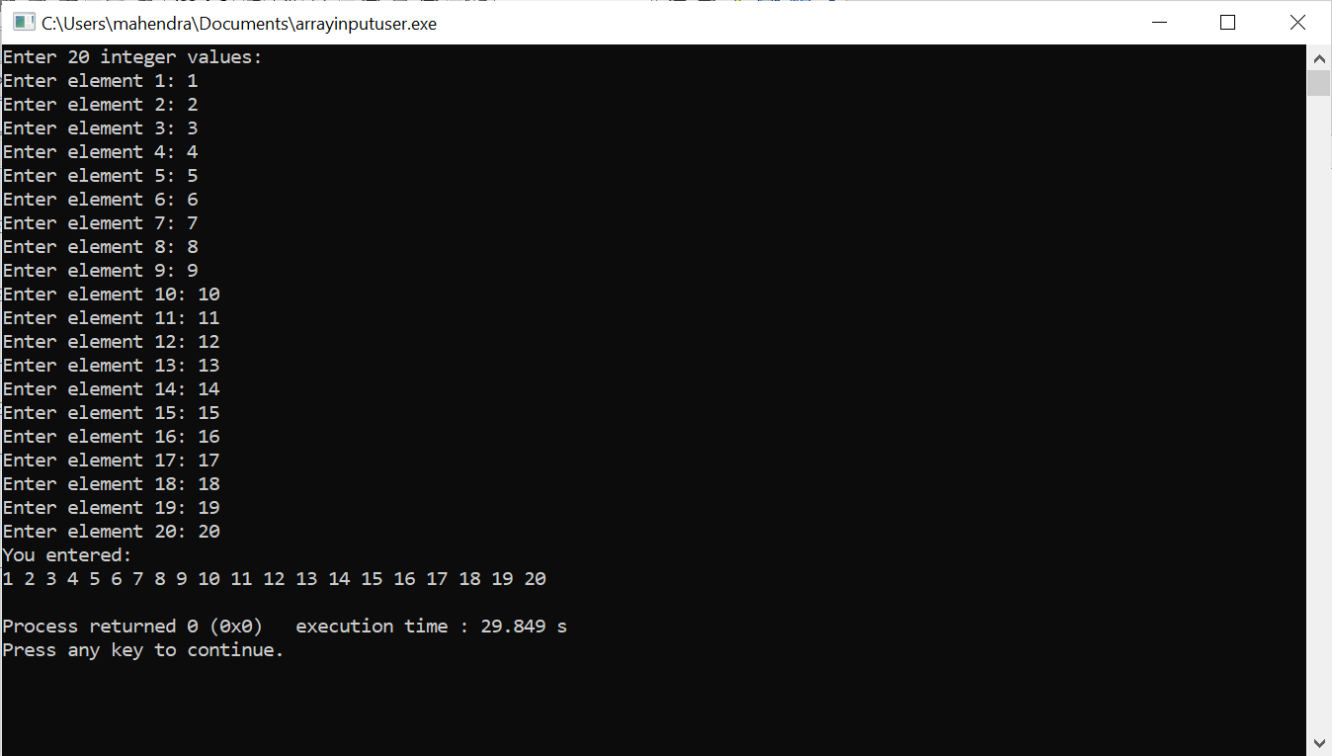

**Write a program to search the indexes in array.**

**Program:**

#include <stdio.h>

int binarySearch(int arr[], int size, int key) {

int left = 0, right = size - 1;

while (left <= right) {

int mid = left + (right - left) / 2;

if (arr[mid] == key)

return mid;

if (arr[mid] < key)

left = mid + 1;

else

right = mid - 1;

}

return -1;

}

int main() {

int size, key;

printf("Enter the size of the array: ");

scanf("%d", &size);

int arr[size];

printf("Enter %d sorted elements into the array:\n", size);

for (int i = 0; i < size; i++) {

printf("Element %d: ", i + 1);

scanf("%d", &arr[i]);

}

printf("Enter the key to search: ");

scanf("%d", &key);

int result = binarySearch(arr, size, key);

if (result != -1)

printf("Element found at index: %d\n", result);

else

printf("Element not found in the array\n");

return 0;

}

**Output:**

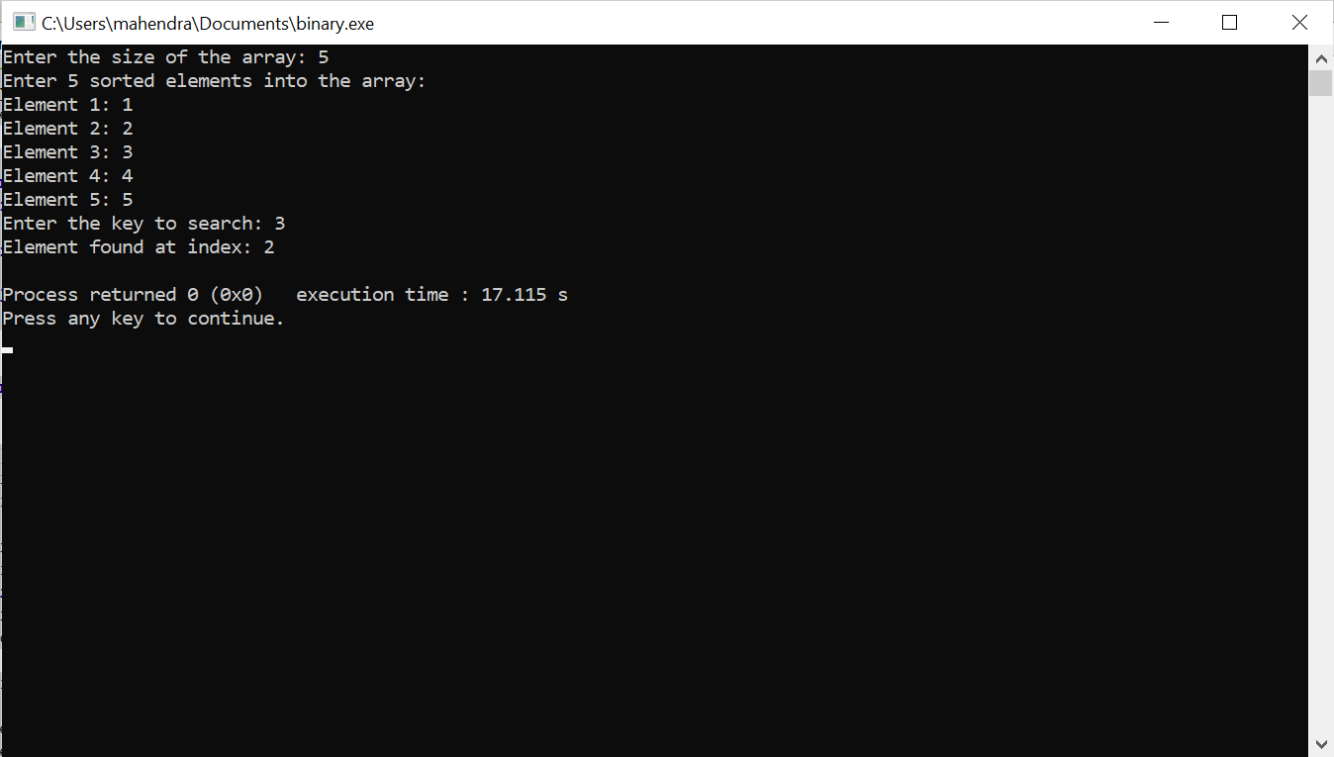

**Write a program to delete indexes in array.**

**Program:**

#include <stdio.h>

int main() {

int a[15] = {1, 2, 3, 4, 5, 6, 7, 8, 9, 10, 11, 12, 13, 14, 15};

int delete_index;

int i, j;

printf("Enter the index of the element you want to delete (0 to 14): ");

scanf("%d", &delete_index);

if (delete_index < 0 || delete_index >= 15) {

printf("Invalid index!\n");

return 1;

}

for (i = delete_index; i < 14; i++) {

a[i] = a[i + 1];

}

a[14] = 0;

printf("Array after deleting element at index %d:\n", delete_index);

for (i = 0; i < 15; i++) {

printf("%d ", a[i]);

}

return 0;

}

**Output:**

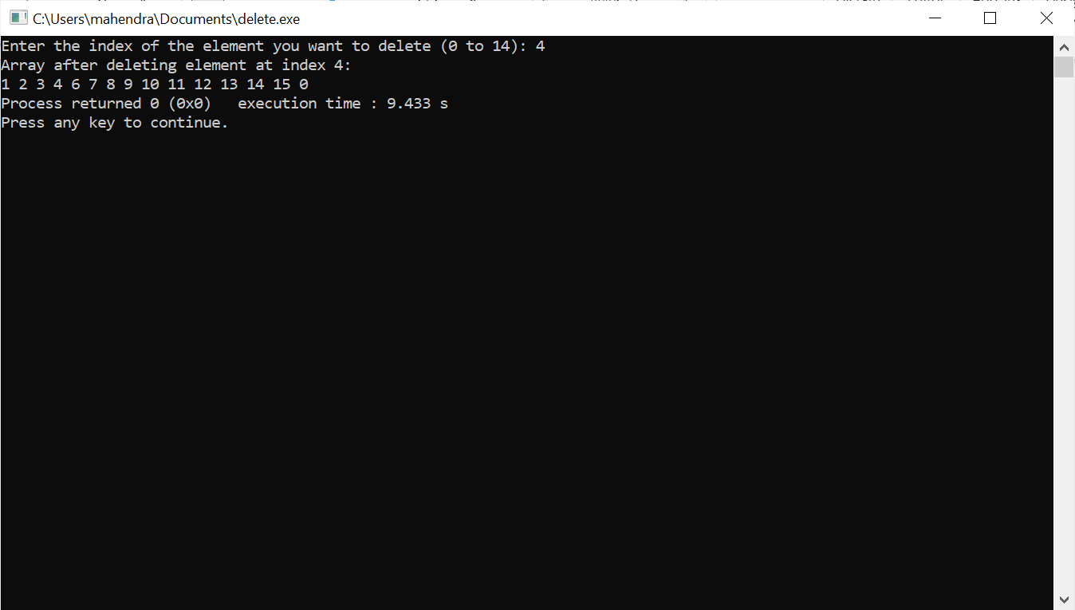

**Write a program on conversions.**

**Program:**

#include<stdio.h>

#include<string.h>

#include<math.h>

void start();

void convert();

void binary_Values();

int bin_to_dec();

void bin_to_oct();

void bin_to_hexa();

void decimal_values();

void dec_to_binary();

void dec_to_oct();

void dec_to_hexa();

void octal_values();

void oct_bin();

void hexa_values();

void hexa_bin();

void wish();

void wish(){

wis:

printf("----------------------------------\n");

printf("Do you wish to Continue?\n");

printf("Press Y to continue or press N to cancel.\n");

printf("----------------------------------\n");

char c;

scanf("%c", &c);

if (c == 'Y' || c == 'y')

{

system("cls");

start();

}

else if(c=='N' || c == 'n') {

printf("Exiting...\n");

return ;

}

else{

printf("Please enter a valid Keyword.\n");

goto wis;

}

}

void start(){

start:

printf("press 1 for Binary Conversions\n");

printf("Press 2 for Decimal Conversions\n");

printf("Press 3 for Octal Conversions\n");

printf("Press 4 for HexDecimal Conversions\n");

printf("Press 5 for Exit Conversions\n");

printf("----------------------------------\n");

int option;

scanf("%d", &option);

if(option ==5){

printf("Exiting.....!\n");

return ;

}

else if(option>4){

printf("Choose the correct option\n");

printf("----------------------------------\n");

goto start;

}

else{

convert(option);

}

}

void convert(int a){

switch (a)

{

case 1:

binary_Values();

wish();

break;

case 2:

decimal_values();

wish();

break;

case 3:

octal_values();

wish();

break;

case 4:

hexa_values();

wish();

break;

default:

break;

}

}

void binary_Values(){

bin:

printf("Please Enter the Binary Value\n");

char a[20];

scanf("%s",a);

for(int i=0;i<20;i++)

{

if(!a[i]==0 && !a[i]==1){

printf("Enter the Binary Values only\n");

goto bin;

}

}

printf("Decimal value of %s is : %d\n",a,bin_to_dec(a));

bin_to_oct(a);

bin_to_hexa(a);

}

int bin_to_dec(char a[]){

int dec=0;

int c=0;

for(int i=strlen(a)-1;i>=0;i--){

dec=dec+(a[i]-'0')*(int)pow(2,c);

c++;

}

return dec;

}

void bin_to_oct(char a[]){

int dec=bin_to_dec(a);

char a1[20];

sprintf(a1,"%o",dec);

printf("Octal value of %s is : %s\n",a,a1);

}

void bin_to_hexa(char a[]){

int dec=bin_to_dec(a);

char a1[20];

sprintf(a1,"%x",dec);

printf("Hexa value of %s is: %s\n",a,a1);

}

void decimal_values(){

printf("Enter a decimal value:\n");

int i;

scanf("%d",&i);

if(!i>0){

printf("Enter a decimal value\n");

}

dec_to_binary(i);

dec_to_oct(i);

dec_to_hexa(i);

}

void dec_to_binary(int a){

int c=0;

int bin[20];

while(a>0){

bin[c++]=a%2;

a=a/2;

}

printf("Binary value of %d is :",a);

for(int i=c-1;i>=0;i--){

printf("%d",bin[i]);

}

printf("\n");

}

void dec_to_oct(int a){

char dec[20];

sprintf(dec, "%o",a);

printf("Octal value of %d is :%s\n",a,dec);

}

void dec_to_hexa(int a){

char hex[20];

sprintf(hex, "%x",a);

printf("Hexadecimal value of %d is :%s\n",a,hex);

}

void octal_values(){

printf("Enter your Octal Number:\n");

char i[20];

scanf("%s",i);

oct_bin(i);

}

void oct_bin(char a[]){

int dec=0;

int c=0;

for(int i=strlen(a)-1;i>=0;i--){

dec=dec+(a[i]-'0')*(int)pow(8,c);

c++;

}

printf("Decimal Value of %s is :%d\n",a,dec);

dec_to_binary(dec);

dec_to_hexa(dec);

}

void hexa_values(){

hexa:

printf("Enter the hexadecimal Values\n");

char c[20];

scanf("%s",c);

for(int i=0;i<strlen(c);i++){

if((c[i]>='0' && c[i]<='9') || (c[i]>='a' && c[i]<='f')){

}

else{

printf("Invalid hexadecimal value\n");

// system("cls");

goto hexa;

}

}

hexa_bin(c);

}

void hexa_bin(char a[]){

int dec=0;

int c=0;

for(int i=strlen(a)-1;i>=0;i--){

if((a[i]>='0' && a[i]<='9')){

dec=dec+(a[i]-'0')*(int)pow(16,c);

}

else{

dec=dec+(a[i]-'a'+10)*(int)pow(16,c);

}

c++;

}

printf("Decimal Value of %s is: %d\n",a,dec);

dec_to_binary(dec);

dec_to_oct(dec);

}

int main(){

printf("Welcome to OMG Conersions!\n");

start();

}

**Output:**

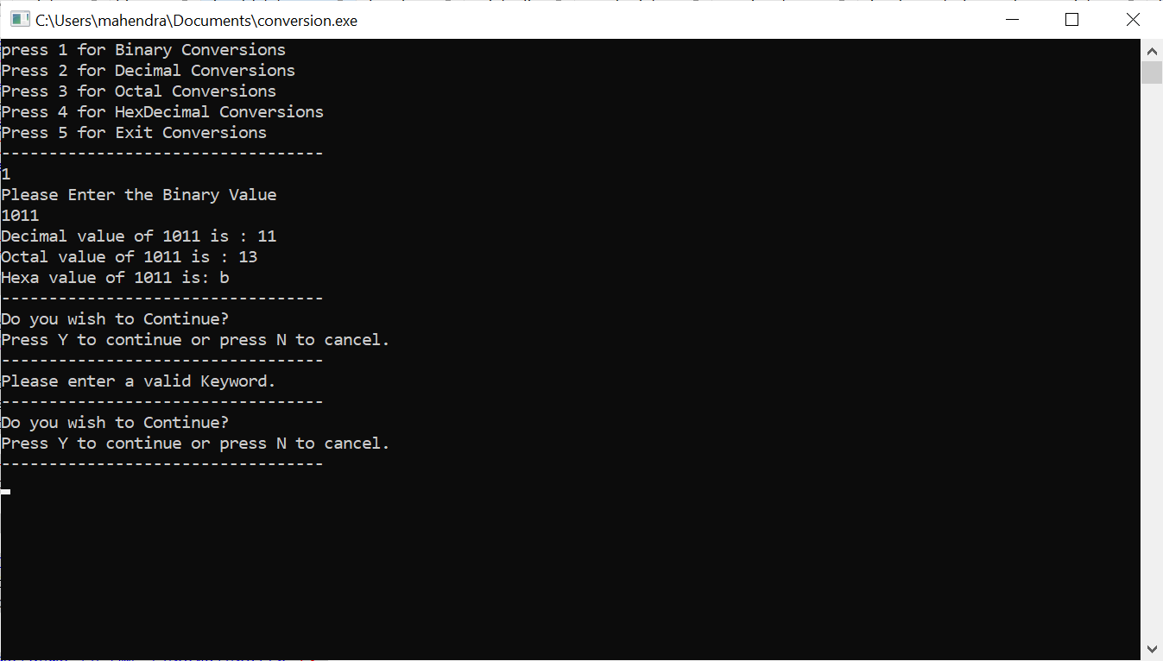

**By using c program to create one file.**

**Program:**

#include <stdio.h>

#include <stdlib.h>

int main()

{

FILE* fptr;

fptr = fopen("file.txt", "w");

if (fptr == NULL) {

printf("The file is not opened. The program will "

"exit now");

exit(0);

}

else {

printf("The file is created Successfully.");

}

return 0;

}

**Output:**

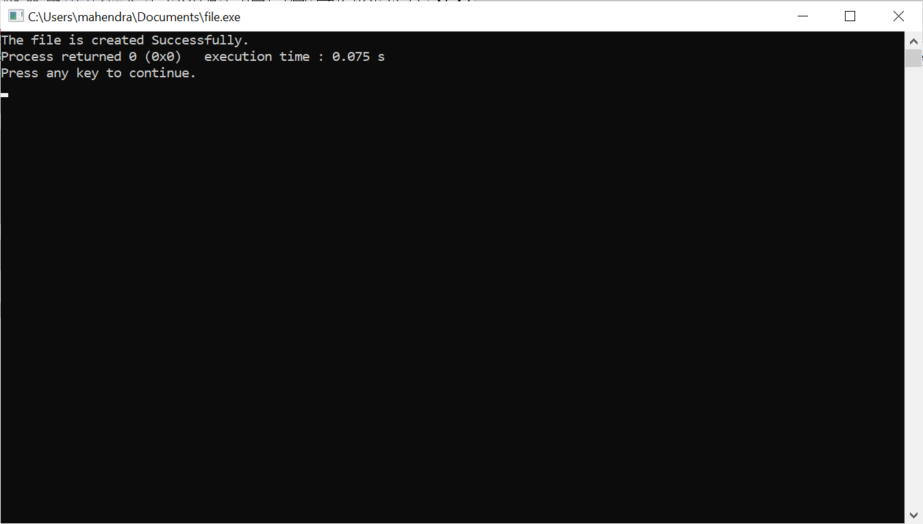

**Write a program on employee management system menu(EMS).**

**Program:**

#include <stdio.h>

#include <stdlib.h>

#include <string.h>

struct Employee {

char name[50];

char department[50];

int age;

};

void createEmployee(struct Employee *empArray, int *numEmployees);

void viewEmployees(struct Employee *empArray, int numEmployees);

void editEmployee(struct Employee *empArray, int numEmployees);

void deleteEmployee(struct Employee *empArray, int *numEmployees);

void saveToFile(struct Employee *empArray, int numEmployees);

int main() {

struct Employee employees[100];

int numEmployees = 0;

int choice;

do {

printf("\nEmployee Management System Menu:\n");

printf("1. Create\n");

printf("2. View\n");

printf("3. Edit\n");

printf("4. Delete\n");

printf("5. Save to File\n");

printf("6. Exit\n");

printf("Enter your choice: ");

scanf("%d", &choice);

switch(choice) {

case 1:

createEmployee(employees, &numEmployees);

break;

case 2:

viewEmployees(employees, numEmployees);

break;

case 3:

editEmployee(employees, numEmployees);

break;

case 4:

deleteEmployee(employees, &numEmployees);

break;

case 5:

saveToFile(employees, numEmployees);

break;

case 6:

printf("Exiting...\n");

break;

default:

printf("Invalid choice! Please enter a number between 1 and 6.\n");

}

} while(choice != 6);

return 0;

}

void createEmployee(struct Employee *empArray, int *numEmployees)

{

if (*numEmployees >= 100)

{

printf("Cannot add more employees. Array is full.\n");

return;

}

printf("Enter employee details:\n");

printf("Name: ");

scanf("%s", empArray[*numEmployees].name);

printf("Department: ");

scanf("%s", empArray[*numEmployees].department);

printf("Age: ");

scanf("%d", &empArray[*numEmployees].age);

(*numEmployees)++;

}

void viewEmployees(struct Employee *empArray, int numEmployees)

{

if (numEmployees == 0)

{

printf("No employees to display.\n");

return;

}

printf("Employee records:\n");

for (int i = 0; i < numEmployees; i++) {

printf("Employee %d:\n", i+1);

printf("Name: %s\n", empArray[i].name);

printf("Department: %s\n", empArray[i].department);

printf("Age: %d\n", empArray[i].age);

printf("\n");

}

}

void editEmployee(struct Employee *empArray, int numEmployees)

{

if (numEmployees == 0)

{

printf("No employees to edit.\n");

return;

}

int empIndex;

printf("Enter the index of the employee to edit (1 to %d): ", numEmployees);

scanf("%d", &empIndex);

empIndex--; // Adjusting index to match array indexing

if (empIndex < 0 || empIndex >= numEmployees)

{

printf("Invalid index!\n");

return;

}

printf("Enter new details for the employee:\n");

printf("Name: ");

scanf("%s", empArray[empIndex].name);

printf("Department: ");

scanf("%s", empArray[empIndex].department);

printf("Age: ");

scanf("%d", &empArray[empIndex].age);

printf("Employee details updated successfully.\n");

}

void deleteEmployee(struct Employee *empArray, int *numEmployees) {

if (*numEmployees == 0) {

printf("No employees to delete.\n");

return;

}

int empIndex;

printf("Enter the index of the employee to delete (1 to %d): ", *numEmployees);

scanf("%d", &empIndex);

empIndex--;

if (empIndex < 0 || empIndex >= *numEmployees) {

printf("Invalid index!\n");

return;

}

for (int i = empIndex; i < *numEmployees - 1; i++) {

strcpy(empArray[i].name, empArray[i + 1].name);

strcpy(empArray[i].department, empArray[i + 1].department);

empArray[i].age = empArray[i + 1].age;

}

(*numEmployees)--;

printf("Employee deleted successfully.\n");

}

void saveToFile(struct Employee *empArray, int numEmployees) {

FILE *filePointer;

filePointer = fopen("employee_records.txt", "w");

if (filePointer == NULL) {

printf("Error opening file!\n");

return;

}

fprintf(filePointer, "Employee Records:\n\n");

for (int i = 0; i < numEmployees; i++) {

fprintf(filePointer, "Employee %d:\n", i+1);

fprintf(filePointer, "Name: %s\n", empArray[i].name);

fprintf(filePointer, "Department: %s\n", empArray[i].department);

fprintf(filePointer, "Age: %d\n\n", empArray[i].age);

}

fclose(filePointer);

printf("Employee records saved to file successfully.\n");

}

**Output:**

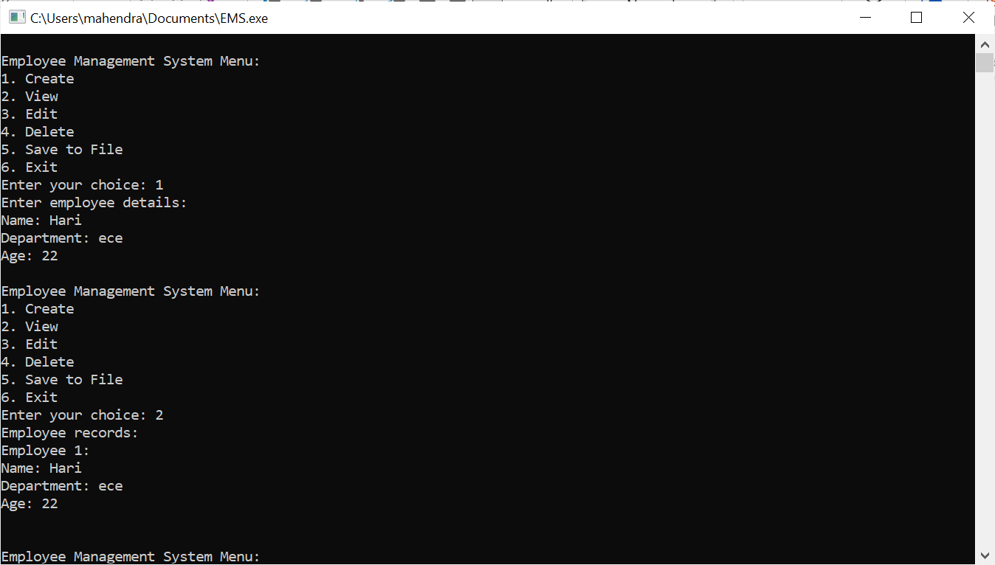

**Write a program to creating index values of array.**

**Program:**

#include <stdio.h>

int main() {

int a[20];

printf("Enter 20 integer values:\n");

for (int i = 0; i < 20; i++) {

printf("Enter element %d: ", i + 1);

scanf("%d", &a[i]);

}

printf("Index\tValue\n");

for (int i = 0; i < 20; i++) {

printf("%d\t%d\n", i, a[i]);

}

return 0;

}

**Output:**

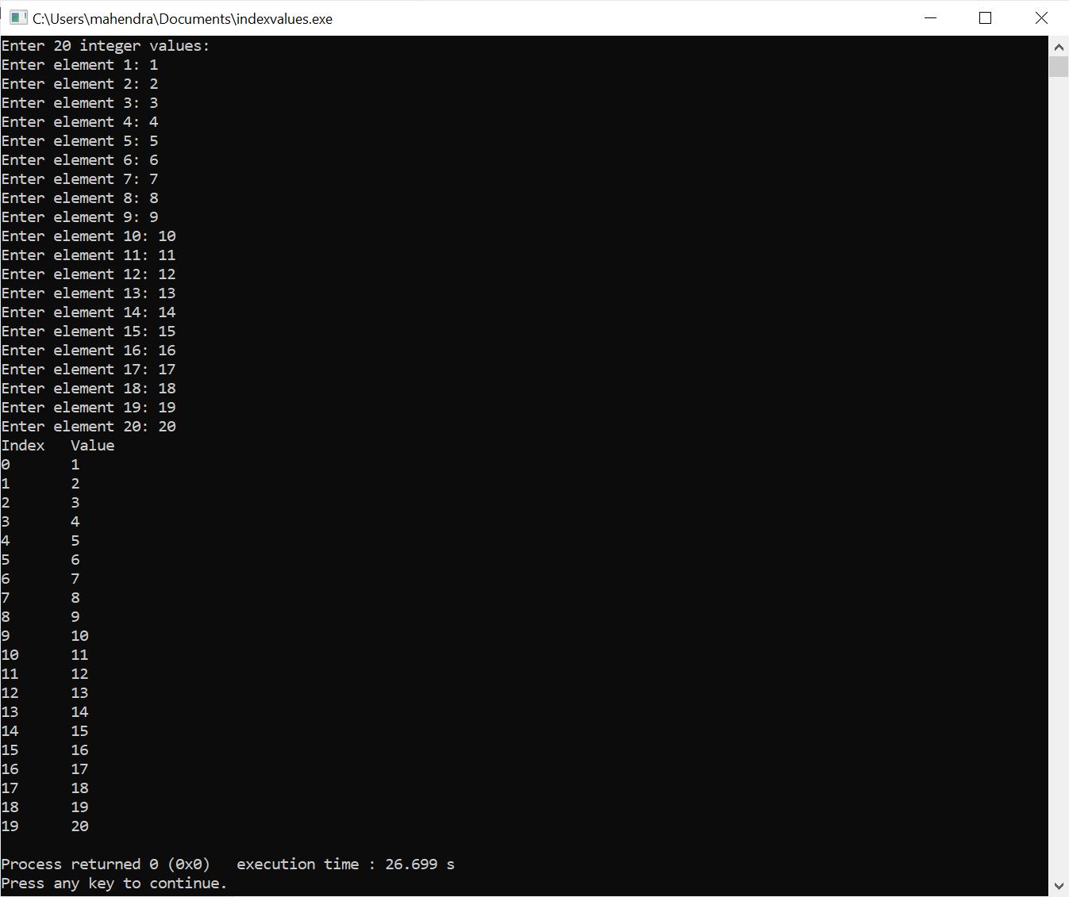

**Write a program on to find no.of bytes occupied in the program .**

**Program:**

#include <stdio.h>

#include <conio.h>

main()

{

printf ("No. of Bytes occupied by int is %d \n", sizeof(int));

printf ("No. of Bytes occupied by float is %d \n", sizeof(float));

printf ("No. of Bytes occupied by double is %d \n", sizeof(double));

printf ("No. of Bytes occupied by char is %d \n", sizeof(char));

printf ("No. of Bytes occupied by long double is %d \n", sizeof(long double));

getch();

}

**Output:**

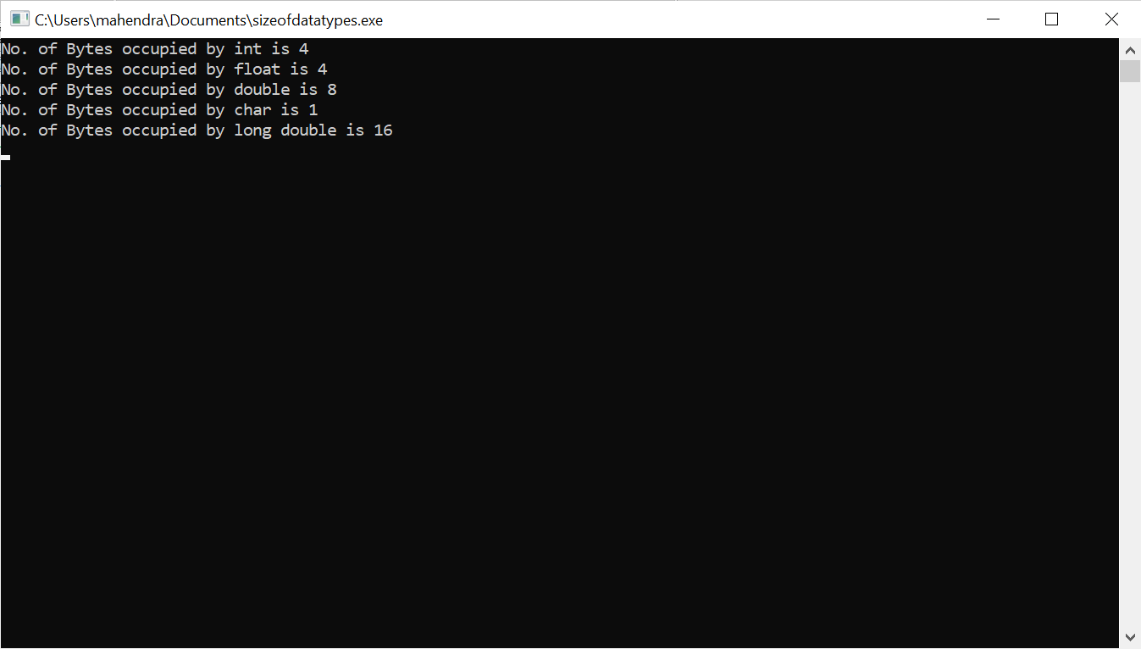

**Write a program to find the sizes of datatype.**

**Program:**

#include <stdio.h>

int main() {

printf("Size of char: %zu byte(s)\n", sizeof(char));

printf("Size of int: %zu byte(s)\n", sizeof(int));

printf("Size of float: %zu byte(s)\n", sizeof(float));

printf("Size of double: %zu byte(s)\n", sizeof(double));

printf("Size of long: %zu byte(s)\n", sizeof(long));

printf("Size of long long: %zu byte(s)\n", sizeof(long long));

printf("Size of bool: %zu byte(s)\n", sizeof(_Bool)); // C99 introduced _Bool for bool type

return 0;

}

**Output:**

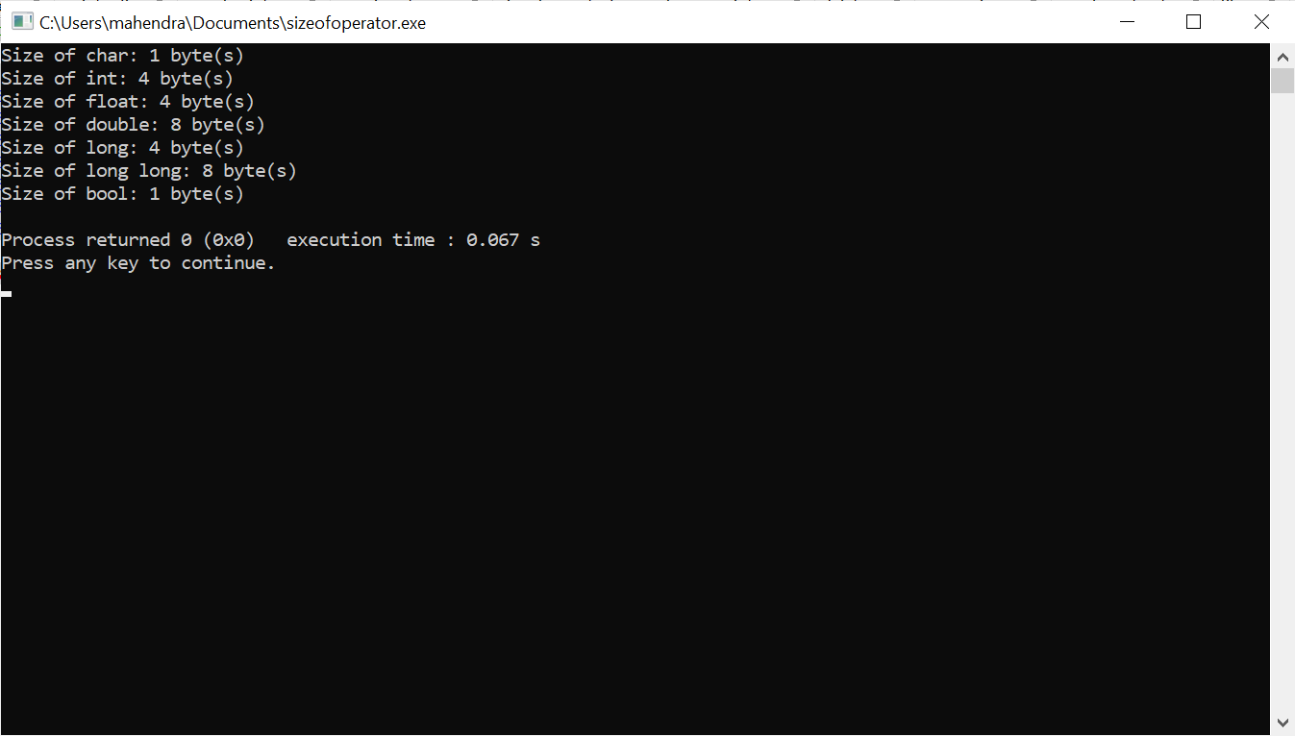

**To create a small project on Airline Booking by using c program.**

**Program:**

#include <stdio.h>

#include <stdlib.h>

#include <string.h>

#include<time.h>

#define MAX_SEATS 50

struct Passenger {

char name[50];

int seat_number;

char date[20];

char source[50];

char destination[50];

};

struct Passenger passengers[MAX_SEATS];

int booked_seats = 0;

void bookSeat() {

if (booked_seats >= MAX_SEATS) {

printf("Sorry, all seats are booked.\n");

return;

}

struct Passenger newPassenger;

printf("Enter passenger name: ");

scanf("%s", newPassenger.name);

printf("Enter booking date (dd/mm/yyyy): ");

scanf("%s", newPassenger.date);

printf("Enter source airport: ");

scanf("%s", newPassenger.source);

printf("Enter destination airport: ");

scanf("%s", newPassenger.destination);

// Check if the date is available for the given source and destination

for (int i = 0; i < booked_seats; i++) {

if (strcmp(passengers[i].date, newPassenger.date) == 0 &&

strcmp(passengers[i].source, newPassenger.source) == 0 &&

strcmp(passengers[i].destination, newPassenger.destination) == 0) {

printf("Sorry, this date is already booked for the given source and destination.\n");

return;

}

}

// Assigning seat number

newPassenger.seat_number = booked_seats + 1;

passengers[booked_seats] = newPassenger;

booked_seats++;

printf("Seat booked successfully. Your seat number is %d.\n", newPassenger.seat_number);

}

void displayPassengers() {

printf("Passenger List:\n");

printf("Seat No.\tName\tBooking Date\tSource\tDestination\n");

for (int i = 0; i < booked_seats; i++) {

printf("%d\t\t%s\t%s\t%s\t%s\n", passengers[i].seat_number, passengers[i].name,

passengers[i].date, passengers[i].source, passengers[i].destination);

}

}

int main() {

int choice;

do {

printf("\nAirline Booking System\n");

printf("1. Book a Seat\n");

printf("2. Display Passenger List\n");

printf("3. Check Date Availability\n");

printf("4. Exit\n");

printf("Enter your choice: ");

scanf("%d", &choice);

switch (choice) {

case 1:

bookSeat();

break;

case 2:

displayPassengers();

break;

case 3: {

char date[20];

char source[50];

char destination[50];

int available = 1;

printf("Enter date to check (dd/mm/yyyy): ");

scanf("%s", date);

printf("Enter source airport: ");

scanf("%s", source);

printf("Enter destination airport: ");

scanf("%s", destination);

// Check if the date is available for the given source and destination

for (int i = 0; i < booked_seats; i++) {

if (strcmp(passengers[i].date, date) == 0 &&

strcmp(passengers[i].source, source) == 0 &&

strcmp(passengers[i].destination, destination) == 0) {

printf("Date %s is not available for the given source and destination.\n", date);

available = 0;

break;

}

}

if (available)

printf("Date %s is available for the given source and destination.\n", date);

break;

}

case 4:

printf("Exiting program.\n");

break;

default:

printf("Invalid choice. Please try again.\n");

}

} while (choice != 4);

return 0;

}

**Output:**

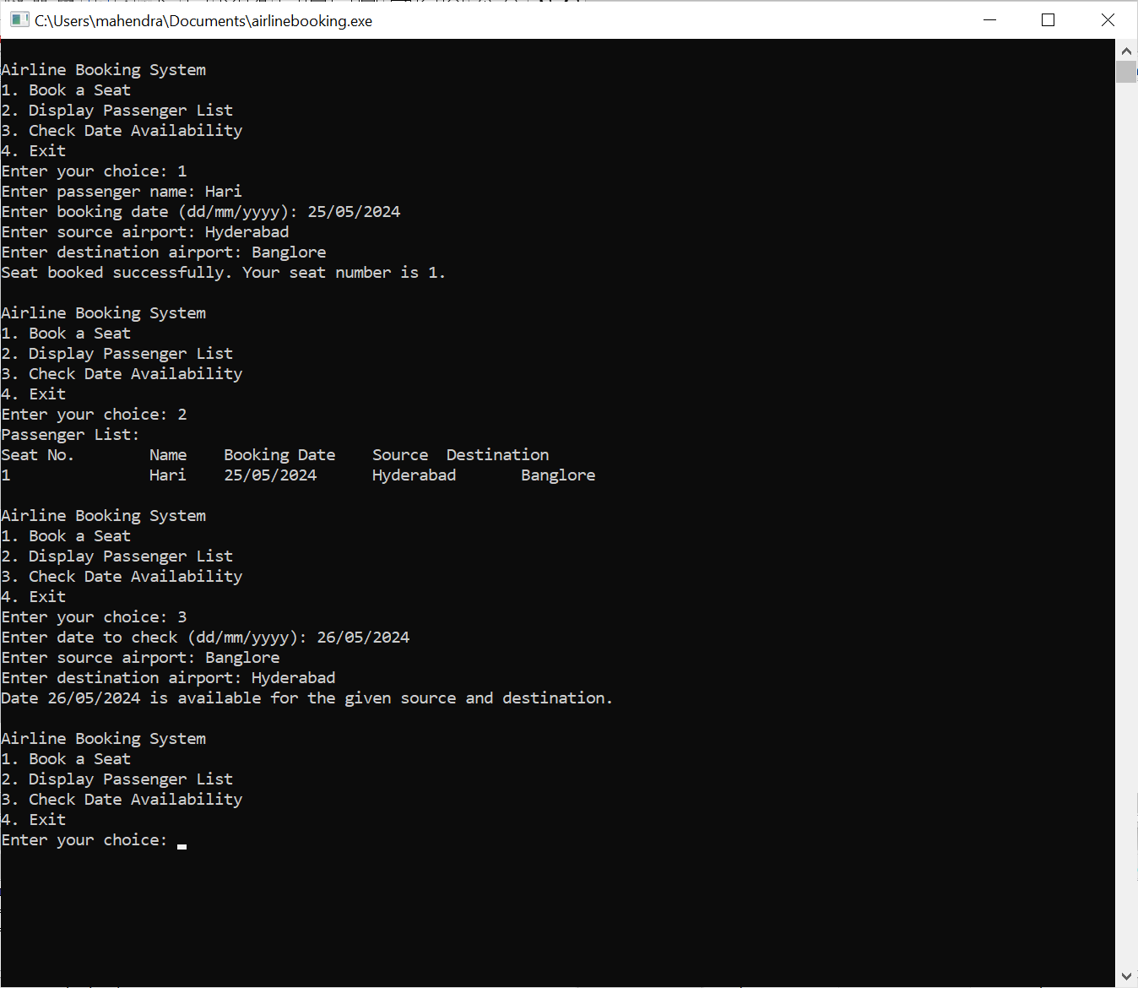

**Write a program on bubble sort.**

**Program:**

#include <stdio.h>

#include <stdlib.h>

// Function to perform bubble sort

void bubbleSort(int *arr, int n) {

int temp;

for (int i = 0; i < n - 1; i++) {

for (int j = 0; j < n - i - 1; j++) {

if (*(arr + j) > *(arr + j + 1)) {

// Swap the elements if they are in the wrong order

temp = *(arr + j);

*(arr + j) = *(arr + j + 1);

*(arr + j + 1) = temp;

}

}

}

}

int main() {

int n;

printf("Enter the number of elements: ");

scanf("%d", &n);

// Dynamically allocate memory for the array

int *arr = (int *)malloc(n * sizeof(int));

// Input the array elements

printf("Enter %d elements:\n", n);

for (int i = 0; i < n; i++) {

scanf("%d", arr + i);

}

// Perform bubble sort

bubbleSort(arr, n);

// Output the sorted array

printf("Sorted array:\n");

for (int i = 0; i < n; i++) {

printf("%d ", *(arr + i));

}

printf("\n");

// Free dynamically allocated memory

free(arr);

return 0;

}

**Output:**

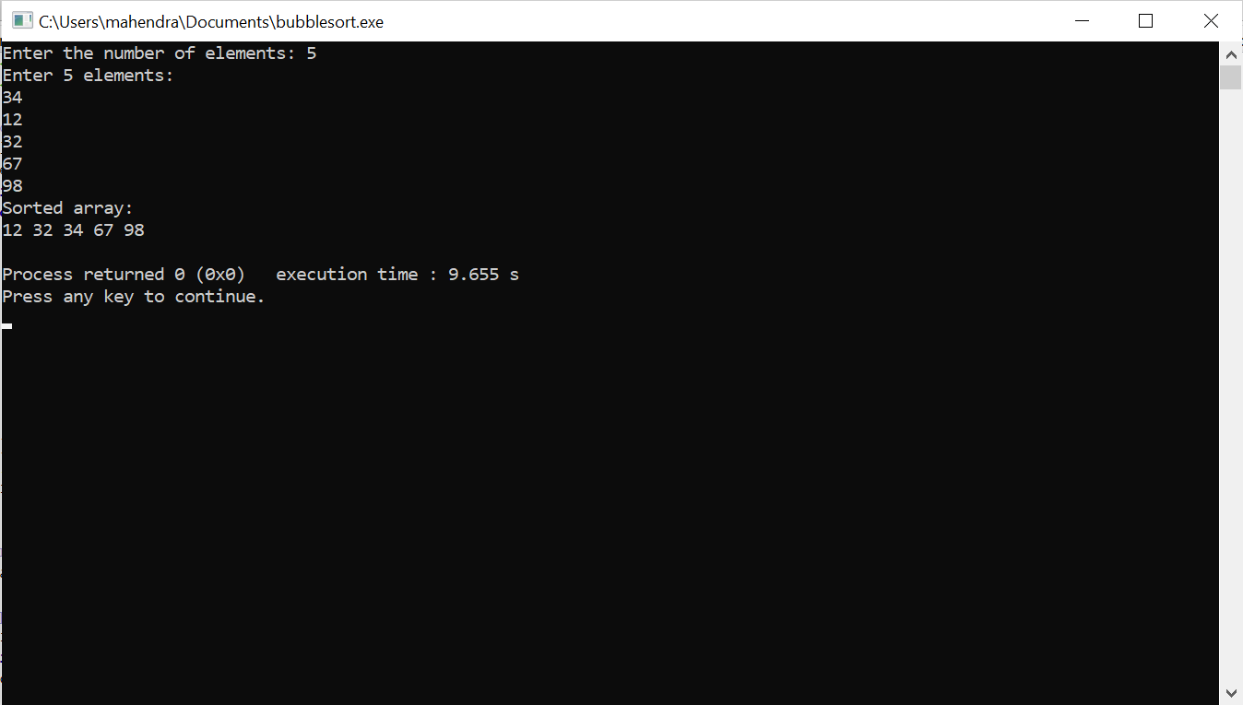

**Write a program by using linkedlist to create a student details delete student record by using student data.**

**Program:**

#include <stdio.h>

#include <stdlib.h>

#include <string.h>

struct Student {

char name[50];

int age;

int rollNumber;

struct Student *next;

};

struct Student* createStudent(char name[], int age, int rollNumber) {

struct Student* newStudent = (struct Student*)malloc(sizeof(struct Student));

strcpy(newStudent->name, name);

newStudent->age = age;

newStudent->rollNumber = rollNumber;

newStudent->next = NULL;

return newStudent;

}

void insertStudent(struct Student** head, char name[], int age, int rollNumber) {

struct Student* newStudent = createStudent(name, age, rollNumber);

if (*head == NULL) {

*head = newStudent;

} else {

struct Student* temp = *head;

while (temp->next != NULL) {

temp = temp->next;

}

temp->next = newStudent;

}

}

void displayStudents(struct Student* head) {

if (head == NULL) {

printf("No students in the list\n");

return;

}

struct Student* temp = head;

while (temp != NULL) {

printf("Name: %s, Age: %d, Roll Number: %d\n", temp->name, temp->age, temp->rollNumber);

temp = temp->next;

}

}

void deleteStudent(struct Student** head, int rollNumber) {

if (*head == NULL) {

printf("List is empty, nothing to delete\n");

return;

}

struct Student *prev = NULL, *curr = *head;

while (curr != NULL && curr->rollNumber != rollNumber) {

prev = curr;

curr = curr->next;

}

if (curr == NULL) {

printf("Student with roll number %d not found\n", rollNumber);

return;

}

if (prev == NULL) {

*head = curr->next;

} else {

prev->next = curr->next;

}

free(curr);

printf("Student with roll number %d deleted successfully\n", rollNumber);

}

int main() {

struct Student* head = NULL;

char name[50];

int age, rollNumber;

for (int i = 0; i < 3; i++) {

printf("Enter details for student %d:\n", i + 1);

printf("Name: ");

scanf("%s", name);

printf("Age: ");

scanf("%d", &age);

printf("Roll Number: ");

scanf("%d", &rollNumber);

insertStudent(&head, name, age, rollNumber);

}

printf("\nDetails of all students:\n");

displayStudents(head);

int rollToDelete;

printf("\nEnter the roll number of the student to delete: ");

scanf("%d", &rollToDelete);

deleteStudent(&head, rollToDelete);

printf("\nDetails of students after deletion:\n");

displayStudents(head);

struct Student* temp;

while (head != NULL) {

temp = head;

head = head->next;

free(temp);

}

return 0;

}

**Output:**

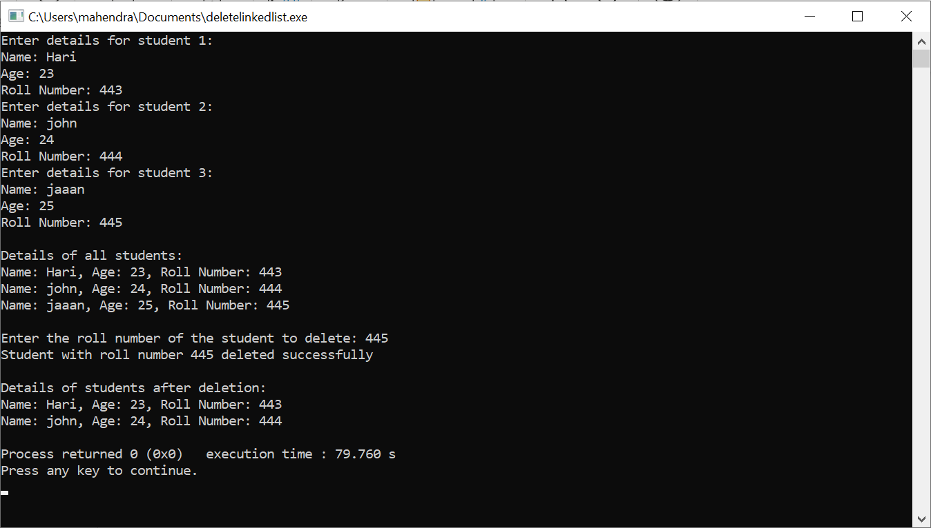

**Write a program by using doubly linked list to printing the data like left address, value,right address,current address.**

**Program:**

#include <stdio.h>

#include <stdlib.h>

struct Node {

int data;

struct Node *left;

struct Node *right;

};

struct Node *head;

void create(int data){

struct Node * nn=(struct Node *)malloc(sizeof(struct Node));

struct Node *h=head;

nn->data=data;

nn->left=NULL;

nn->right=NULL;

if(h==NULL){

head=nn;

return ;

}

while(h->right!=NULL){

h=h->right;

}

h->right=nn;

nn->left=h;

}

void display(){

struct Node *h=head;

while(h!=NULL){

printf("Left Address is :: %u || Value ::%d || Right Address is ::%u || Current Address :: %u\n",h->left,h->data,h->right,h);

h=h->right;

}

}

int main(){

create(10);

create(23);

create(30);

create(40);

printf("Printing the data...\n");

display();

}

**Output:**

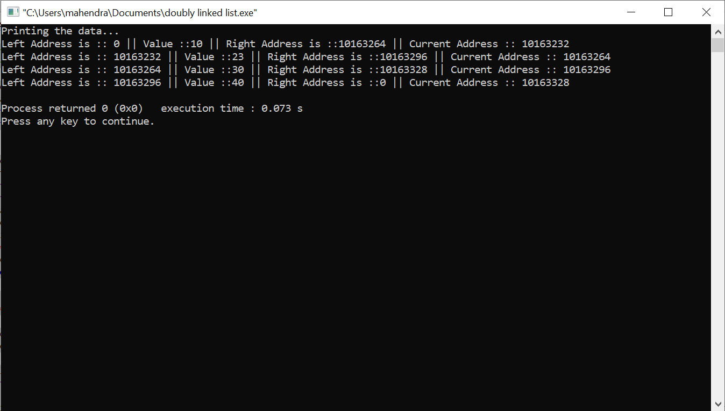

**Write a program on c to create employee management system file like create data ,modify data, view data.**

**Program:**

#include <stdio.h> ///for input output functions like printf, scanf

#include <stdlib.h>

#include <conio.h>

#include <windows.h> ///for windows related functions (not important)

#include <string.h> ///string operations

/** List of Global Variable */

COORD coord = {0,0}; /// top-left corner of window

/**

function : gotoxy

@param input: x and y coordinates

@param output: moves the cursor in specified position of console

*/

void gotoxy(int x,int y)

{

coord.X = x;

coord.Y = y;

SetConsoleCursorPosition(GetStdHandle(STD_OUTPUT_HANDLE),coord);

}

/** Main function started */

int main()

{

FILE *fp, *ft; /// file pointers

char another, choice;

/** structure that represent a employee */

struct emp

{

char name[40]; ///name of employee

int age; /// age of employee

float bs; /// basic salary of employee

};

struct emp e; /// structure variable creation

char empname[40]; /// string to store name of the employee

long int recsize; /// size of each record of employee

/** open the file in binary read and write mode

* if the file EMP.DAT already exists then it open that file in read write mode

* if the file doesn't exit it simply create a new copy

*/

fp = fopen("EMP.DAT","rb+");

if(fp == NULL)

{

fp = fopen("EMP.DAT","wb+");

if(fp == NULL)

{

printf("Connot open file");

exit(1);

}

}

/// sizeo of each record i.e. size of structure variable e

recsize = sizeof(e);

/// infinite loop continues untile the break statement encounter

while(1)

{

system("cls"); ///clear the console window

gotoxy(30,10); /// move the cursor to postion 30, 10 from top-left corner

printf("1. Add Record"); /// option for add record

gotoxy(30,12);

printf("2. List Records"); /// option for showing existing record

gotoxy(30,14);

printf("3. Modify Records"); /// option for editing record

gotoxy(30,16);

printf("4. Delete Records"); /// option for deleting record

gotoxy(30,18);

printf("5. Exit"); /// exit from the program

gotoxy(30,20);

printf("Your Choice: "); /// enter the choice 1, 2, 3, 4, 5

fflush(stdin); /// flush the input buffer

choice = getche(); /// get the input from keyboard

switch(choice)

{

case '1': /// if user press 1

system("cls");

fseek(fp,0,SEEK_END); /// search the file and move cursor to end of the file

/// here 0 indicates moving 0 distance from the end of the file

another = 'y';

while(another == 'y') /// if user want to add another record

{

printf("\nEnter name: ");

scanf("%s",e.name);

printf("\nEnter age: ");

scanf("%d", &e.age);

printf("\nEnter basic salary: ");

scanf("%f", &e.bs);

fwrite(&e,recsize,1,fp); /// write the record in the file

printf("\nAdd another record(y/n) ");

fflush(stdin);

another = getche();

}

break;

case '2':

system("cls");

rewind(fp); ///this moves file cursor to start of the file

while(fread(&e,recsize,1,fp)==1) /// read the file and fetch the record one record per fetch

{

printf("\n%s %d %.2f",e.name,e.age,e.bs); /// print the name, age and basic salary

}

getch();

break;

case '3': /// if user press 3 then do editing existing record

system("cls");

another = 'y';

while(another == 'y')

{

printf("Enter the employee name to modify: ");

scanf("%s", empname);

rewind(fp);

while(fread(&e,recsize,1,fp)==1) /// fetch all record from file

{

if(strcmp(e.name,empname) == 0) ///if entered name matches with that in file

{

printf("\nEnter new name,age and bs: ");

scanf("%s%d%f",e.name,&e.age,&e.bs);

fseek(fp,-recsize,SEEK_CUR); /// move the cursor 1 step back from current position

fwrite(&e,recsize,1,fp); /// override the record

break;

}

}

printf("\nModify another record(y/n)");

fflush(stdin);

another = getche();

}

break;

case '4':

system("cls");

another = 'y';

while(another == 'y')

{

printf("\nEnter name of employee to delete: ");

scanf("%s",empname);

ft = fopen("Temp.dat","wb"); /// create a intermediate file for temporary storage

rewind(fp); /// move record to starting of file

while(fread(&e,recsize,1,fp) == 1) /// read all records from file

{

if(strcmp(e.name,empname) != 0) /// if the entered record match

{

fwrite(&e,recsize,1,ft); /// move all records except the one that is to be deleted to temp file

}

}

fclose(fp);

fclose(ft);

remove("EMP.DAT"); /// remove the orginal file

rename("Temp.dat","EMP.DAT"); /// rename the temp file to original file name

fp = fopen("EMP.DAT", "rb+");

printf("Delete another record(y/n)");

fflush(stdin);

another = getche();

}

break;

case '5':

fclose(fp); /// close the file

exit(0); /// exit from the program

}

}

return 0;

}

**Output:**

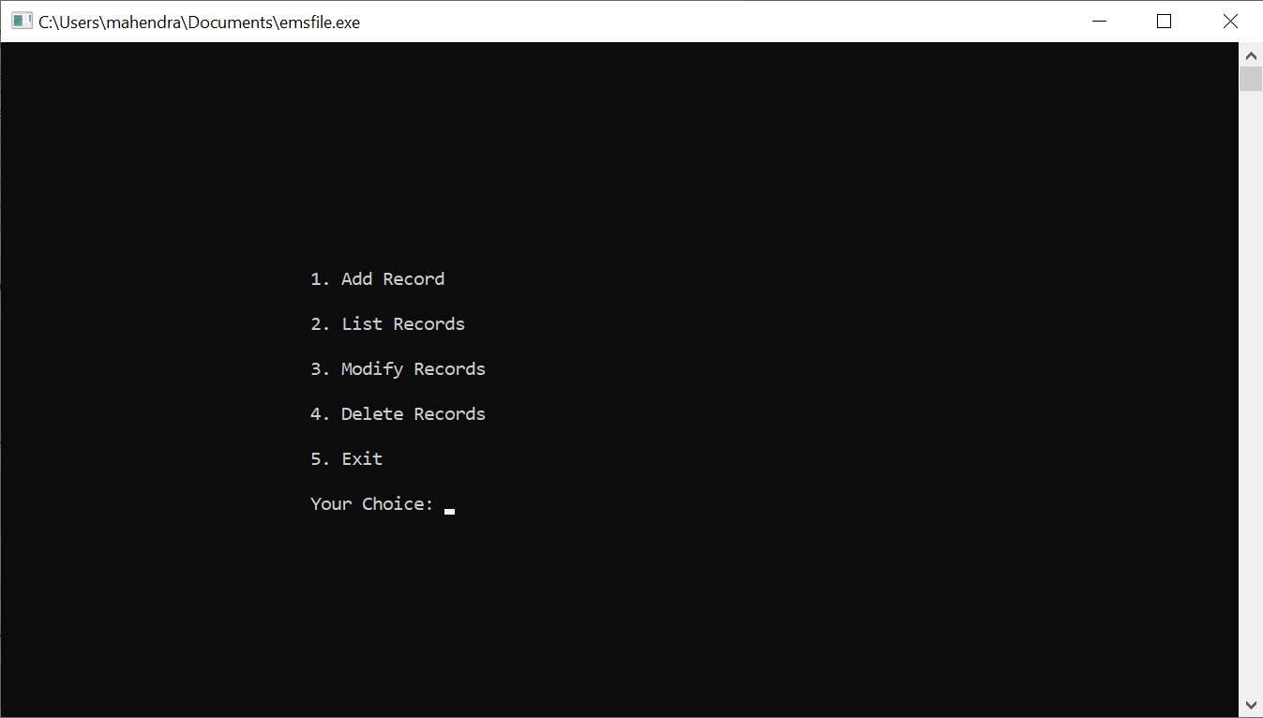

**1)Add record**

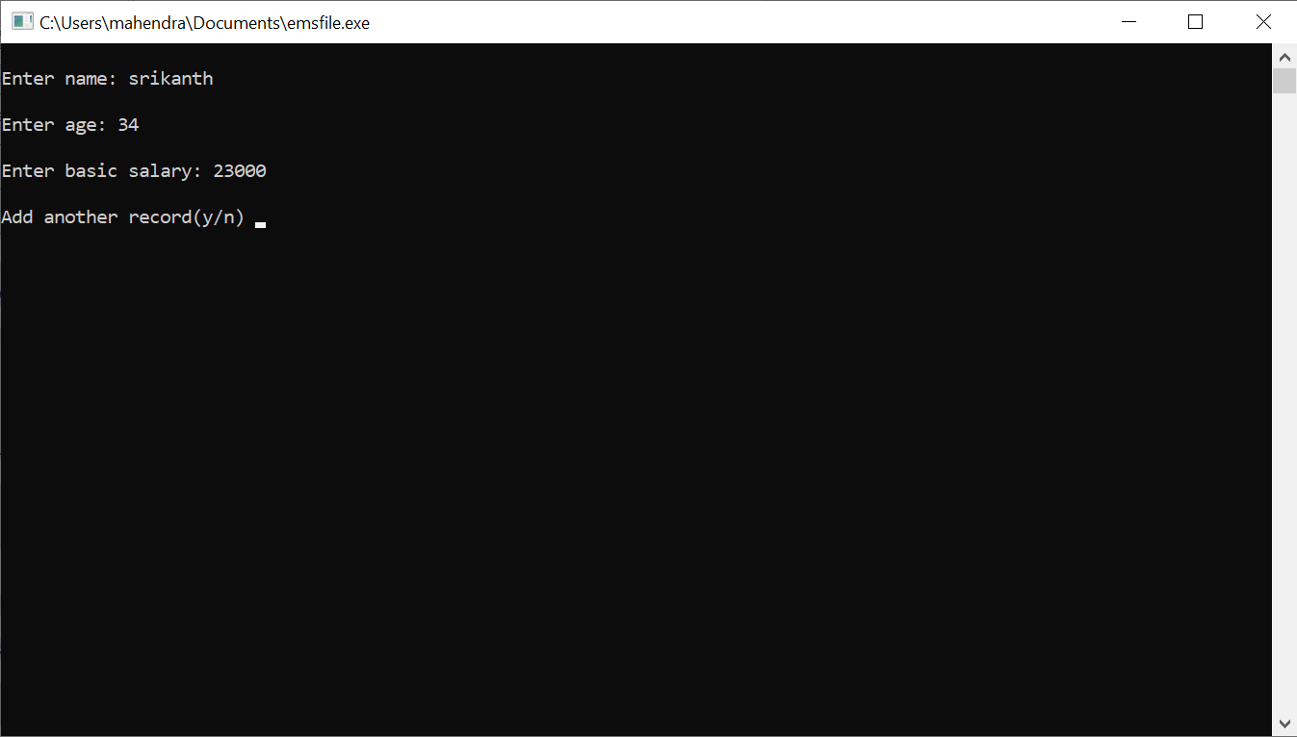

**2)List records**

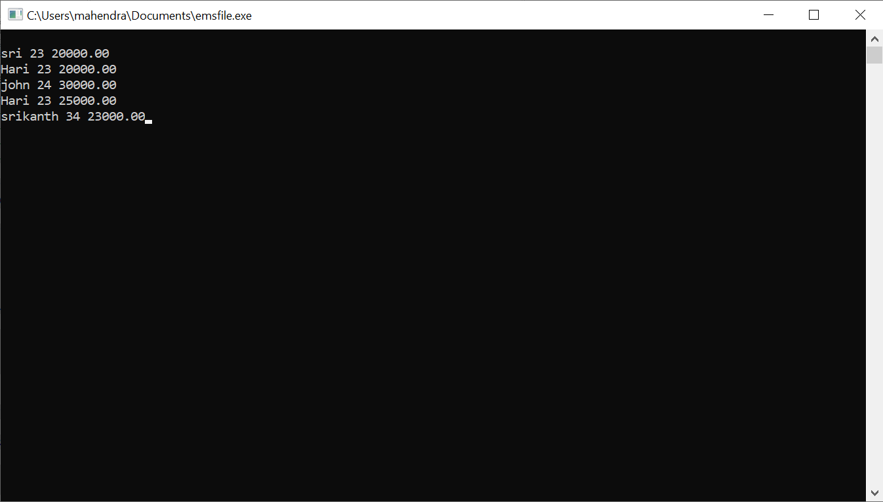

**3)Modify records**

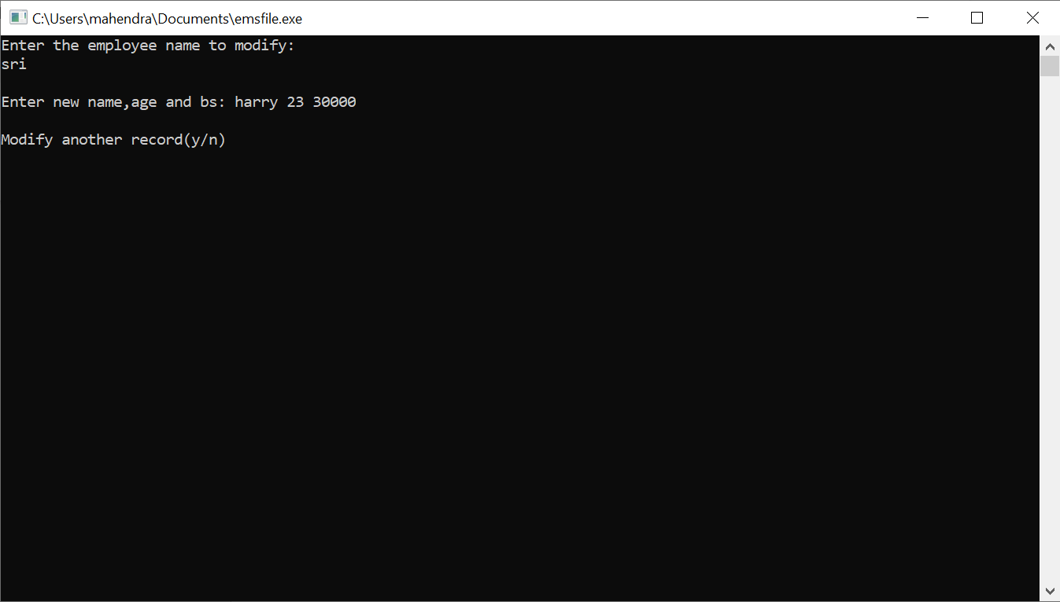

**4)Delete record**

**5)Exit**

**Write a program in c to create a SIMPLE CALCULATOR.**

**Program:**

#include <stdio.h>

int main() {

double num1, num2;

char operator;

double result;

printf("Enter to my calculator/n:");

printf("Enter first number: ");

scanf("%lf", &num1);

printf("Enter an operator (+, -, *, /): ");

scanf(" %c", &operator);

printf("Enter second number: ");

scanf("%lf", &num2);

switch (operator) {

case '+':

result = num1 + num2;

printf("Result: %.2lf + %.2lf = %.2lf\n", num1, num2, result);

break;

case '-':

result = num1 - num2;

printf("Result: %.2lf - %.2lf = %.2lf\n", num1, num2, result);

break;

case '*':

result = num1 * num2;

printf("Result: %.2lf * %.2lf = %.2lf\n", num1, num2, result);

break;

case '/':

if (num2 != 0) {

result = num1 / num2;

printf("Result: %.2lf / %.2lf = %.2lf\n", num1, num2, result);

} else {

printf("Error: Division by zero is not allowed.\n");

}

break;

default:

printf("Error: Invalid operator.\n");

break;

}

return 0;

}

**Output:**

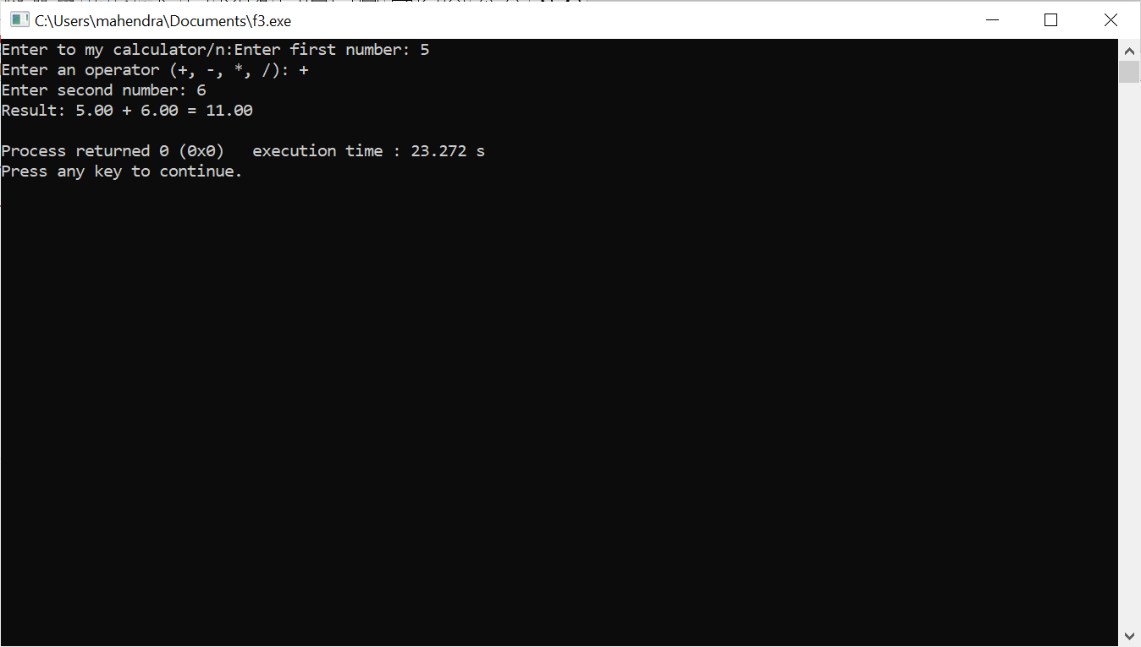

**Write a program on QUEUE.**

**Program:**

**// Queue implementation in C**

#include <stdio.h>

#define SIZE 5

void enQueue(int);

void deQueue();

void display();

int items[SIZE], front = -1, rear = -1;

int main() {

//deQueue is not possible on empty queue

deQueue();

//enQueue 5 elements

enQueue(1);

enQueue(2);

enQueue(3);

enQueue(4);

enQueue(5);

// 6th element can't be added to because the queue is full

enQueue(6);

display();

//deQueue removes element entered first i.e. 1

deQueue();

//Now we have just 4 elements

display();

return 0;

}

void enQueue(int value) {

if (rear == SIZE - 1)

printf("\nQueue is Full!!");

else {

if (front == -1)

front = 0;

rear++;

items[rear] = value;

printf("\nInserted -> %d", value);

}

}

void deQueue() {

if (front == -1)

printf("\nQueue is Empty!!");

else {

printf("\nDeleted : %d", items[front]);

front++;

if (front > rear)

front = rear = -1;

}

}

// Function to print the queue

void display() {

if (rear == -1)

printf("\nQueue is Empty!!!");

else {

int i;

printf("\nQueue elements are:\n");

for (i = front; i <= rear; i++)

printf("%d ", items[i]);

}

printf("\n");

}

**Output:**

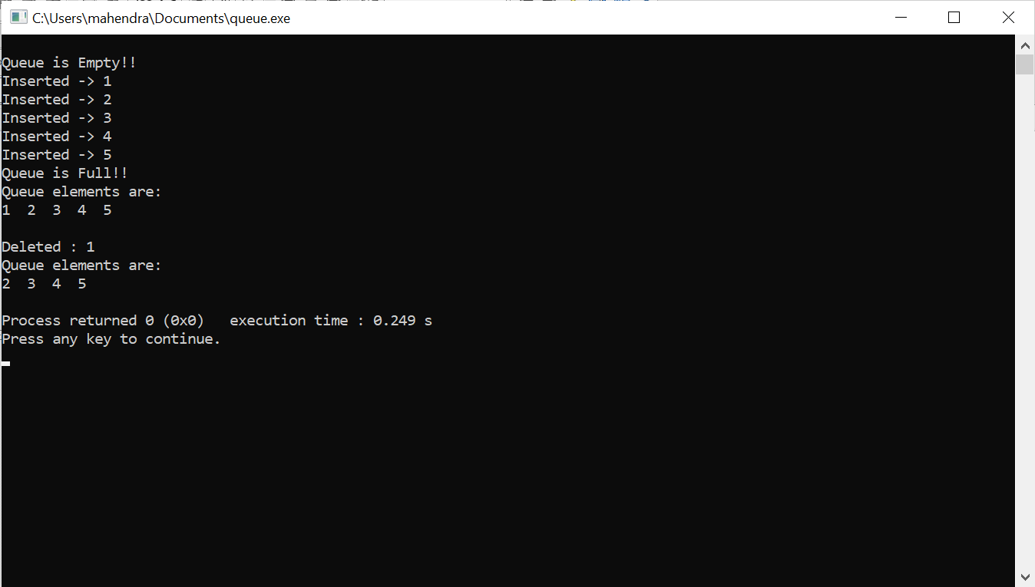

**Write a program in STACK.**

**Program:**

#include <stdio.h>

#include <stdlib.h>

#define MAX 10

int count = 0;

// Creating a stack

struct stack {

int items[MAX];

int top;

};

typedef struct stack st;

void createEmptyStack(st *s) {

s->top = -1;

}

// Check if the stack is full

int isfull(st *s) {

if (s->top == MAX - 1)

return 1;

else

return 0;

}

// Check if the stack is empty

int isempty(st *s) {

if (s->top == -1)

return 1;

else

return 0;

}

// Add elements into stack

void push(st *s, int newitem) {

if (isfull(s)) {

printf("STACK FULL\n");

} else {

s->top++;

s->items[s->top] = newitem;

}

count++;

}

// Remove element from stack

void pop(st *s) {

if (isempty(s)) {

printf("\n STACK EMPTY \n");

} else {

printf("Item popped= %d\n", s->items[s->top]);

s->top--;

}

count--;

}

// Print elements of stack

void printStack(st *s) {

printf("Stack: ");

for (int i = 0; i < count; i++) {

printf("%d ", s->items[i]);

}

printf("\n");

}

// Driver code

int main() {

int ch, item;

st *s = (st *)malloc(sizeof(st));

createEmptyStack(s);

do {

printf("\nStack Operations:\n");

printf("1. Push\n");

printf("2. Pop\n");

printf("3. Display\n");

printf("4. Exit\n");

printf("Enter your choice: ");

scanf("%d", &ch);

switch (ch) {

case 1:

printf("Enter the element to push: ");

scanf("%d", &item);

push(s, item);

break;

case 2:

pop(s);

break;

case 3:

printStack(s);

break;

case 4:

printf("Exiting program\n");

break;

default:

printf("Invalid choice\n");

}

} while (ch != 4);

return 0;

}

**Output:**

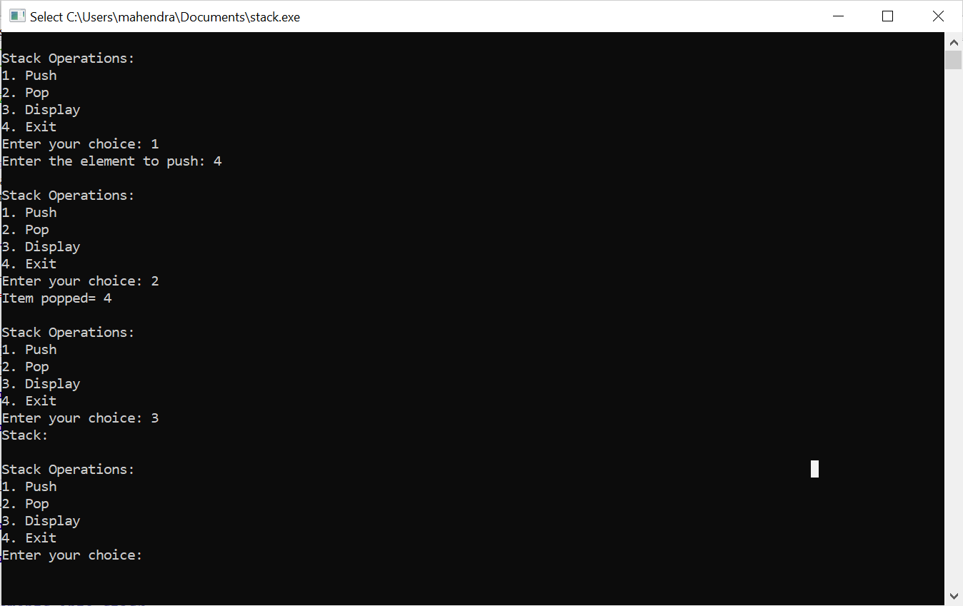

**Write a program in c to create size of operator by using array and pointer**.

**Program:**

#include <stdio.h>

int main() {

int arr[] = {10, 20, 30, 40, 50};

printf("Size of arr: %zu bytes\n", sizeof(arr));

printf("Number of elements in arr: %zu\n", sizeof(arr) / sizeof(arr[0]));

printf("Size of each element in arr: %zu bytes\n", sizeof(arr[0]));

printf("Elements of arr: ");

for (size_t i = 0; i < sizeof(arr) / sizeof(arr[0]); ++i) {

printf("%d ", arr[i]);

}

printf("\n");

int *ptr = arr;

printf("Size of ptr: %zu bytes\n", sizeof(ptr));

printf("Size of data type pointed by ptr: %zu bytes\n", sizeof(*ptr));

printf("Elements of arr using pointer: ");

for (size_t i = 0; i < sizeof(arr) / sizeof(arr[0]); ++i) {

printf("%d ", *(ptr + i));

}

printf("\n");

return 0;

}

**Output:**

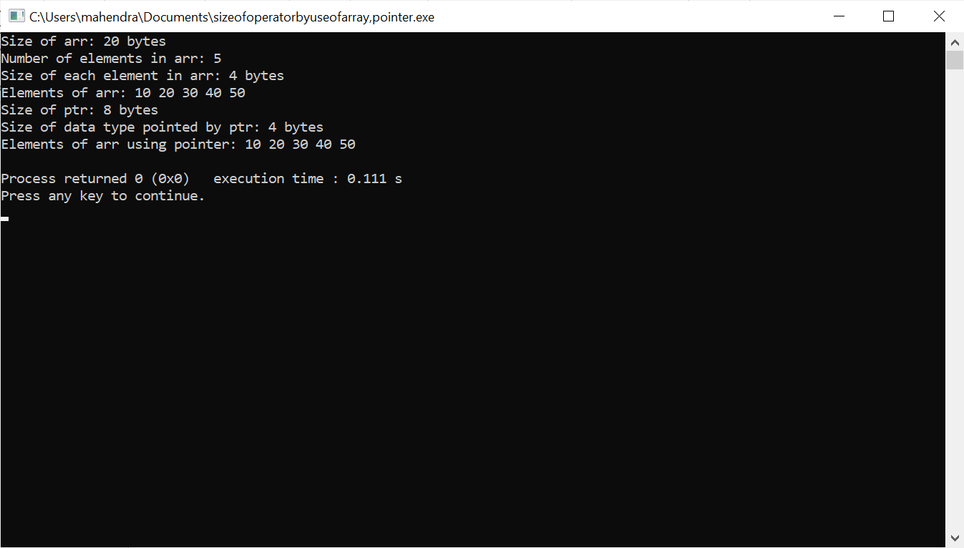

**Write a program in c to create a Tower of hanoi.**

**Program:**

#include <stdio.h>

void hanoi(int n, char from, char to, char via) {

if(n == 1){

printf("Move disk 1 from %c to %c\n", from, to);

}

else{

hanoi(n-1, from, via, to);

printf("Move disk %d from %c to %c\n", n, from, to);

hanoi(n-1, via, to, from);

}

}

int main() {

int n = 4;

char from = 'A';

char to = 'B';

char via = 'C';

//calling hanoi() method

hanoi(n, from, via, to);

}

**Output:**

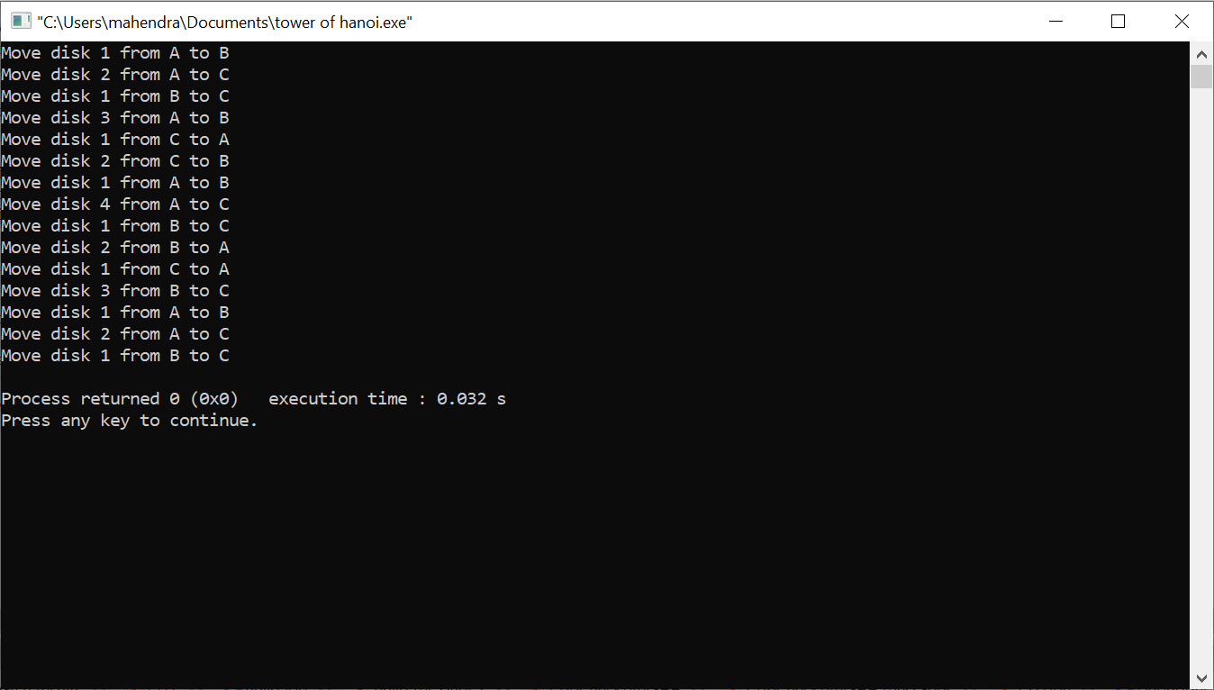

**Write a program in c to create an AVL TREE.**

**Program:**

#include<stdio.h>

#include<stdlib.h>

struct Node {

int key;

struct Node *left;

struct Node *right;

int height;

};

int max(int a, int b);

int height(struct Node *N);

struct Node* newNode(int key);

struct Node* rightRotate(struct Node *y);

struct Node* leftRotate(struct Node *x);

int getBalance(struct Node *N);

struct Node* insert(struct Node* node, int key);

void preOrder(struct Node *root);

void printTree(struct Node* root, int space);

int main() {

struct Node *root = NULL;

int n, key;

printf("Enter the number of elements: ");

scanf("%d", &n);

printf("Enter the elements: ");

for (int i = 0; i < n; i++) {

scanf("%d", &key);

root = insert(root, key);

}

printf("Preorder traversal of the constructed AVL tree is: ");

preOrder(root);

printf("\n");

printf("Graphical representation of the AVL tree:\n");

printTree(root, 0);

return 0;

}

int max(int a, int b) {

return (a > b) ? a : b;

}

int height(struct Node *N) {

if (N == NULL)

return 0;

return N->height;

}

struct Node* newNode(int key) {

struct Node* node = (struct Node*)malloc(sizeof(struct Node));

node->key = key;

node->left = NULL;

node->right = NULL;

node->height = 1;

return(node);

}

struct Node* rightRotate(struct Node *y) {

struct Node *x = y->left;

struct Node *T2 = x->right;

x->right = y;

y->left = T2;

y->height = max(height(y->left), height(y->right)) + 1;

x->height = max(height(x->left), height(x->right)) + 1;

return x;

}

struct Node* leftRotate(struct Node *x) {

struct Node *y = x->right;

struct Node *T2 = y->left;

y->left = x;

x->right = T2;

x->height = max(height(x->left), height(x->right)) + 1;

y->height = max(height(y->left), height(y->right)) + 1;

return y;

}

int getBalance(struct Node *N) {

if (N == NULL)

return 0;

return height(N->left) - height(N->right);

}

struct Node* insert(struct Node* node, int key) {

if (node == NULL)

return(newNode(key));

if (key < node->key)

node->left = insert(node->left, key);

else if (key > node->key)

node->right = insert(node->right, key);

else

return node;

node->height = 1 + max(height(node->left), height(node->right));

int balance = getBalance(node);

if (balance > 1 && key < node->left->key)

return rightRotate(node);

if (balance < -1 && key > node->right->key)

return leftRotate(node);

if (balance > 1 && key > node->left->key) {

node->left = leftRotate(node->left);

return rightRotate(node);

}

if (balance < -1 && key < node->right->key) {

node->right = rightRotate(node->right);

return leftRotate(node);

}

return node;

}

void preOrder(struct Node *root) {

if(root != NULL) {

printf("%d ", root->key);

preOrder(root->left);

preOrder(root->right);

}

}

void printTree(struct Node* root, int space) {

if (root == NULL)

return;

space += 10;

printTree(root->right, space);

printf("\n");

for (int i = 10; i < space; i++)

printf(" ");

printf("%d\n", root->key);

printTree(root->left, space);

**}**

**Output:**

